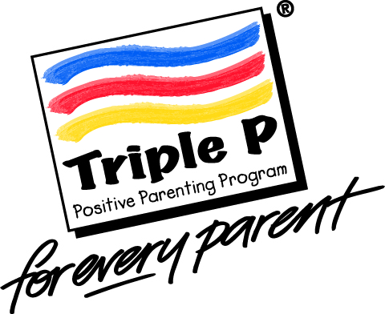

CEFS Parenting Referral Form

Early Help and Preventative Services
Please email all referrals using secure email to Parenting@cheshireeast.gov.uk ensuring that appropriate secure controls are in place such as egress or CJSM. Please refer to your own organisation/agency guidance on the correct secure email method to use.

Deadline for referrals is 4 weeks before the course start date.

CHILDS DETAILS
Surname
Forename(s)
D.O.B/Age |  |  |  |  |  |  | Liquid Logic No
Gender | Male |  |  |  | Female
Current address:
Postcode:
Please identify if the child is subject to any of the following: |  |  |  | Child Protection Plan |  |  |  |  |  |  | Child in Need Plan
 |  |  |  | EHA Plan |  |  |  |  |  |  | EHCP

Attending PARENTS/CARERS DETAILS

(Please note Parents need to be living with their children)
Surname
Forename(s)
Gender | Male |  | Female
Relationship to child
Contact Number
Parent email

Attending Parent 2 Details

Surname
Forename(s)
Gender | Male |  | Female
Relationship to child
Contact Number
Parent email

Parental commitment: Discussed with Parent : Y/N
Please confirm you have discussed the referral with all the parents and agreed what outcomes the parents are seeking from attending the course; that they are fully aware of the commitment required to undertake the course; and that they are committed to attending the whole course before the referral is submitted.

Parents will be contacted within the 4 weeks leading up to the start date of the course.

Please note:
- Parents will only be offered two opportunities to take up a group.
- We do not accept rereferrals for parents to complete the same course again.
- We do not accept referrals for parents to complete multiple courses.
- Parents must have the children living with them.
- Both parents would benefit from attending the course if child is resident.

Transport/Childcare
Transport / child care arrangements should fall to the responsibility of the parents or referring agency. This should be discussed with the parents by the referrer at the time of completing the form. In exceptional circumstances CEFS may consider funding of travel/childcare but these requests must be made by the referrer prior to the start of the course and may not always be available.

Please provide a brief overview of the reason for referral: What are the difficulties the parents are dealing with? What have they tried? What support have you offered?

What are you worried about?

Please provide a summary of the anticipated outcomes you wish for the family as a result of the intervention you are referring for: What are you expecting them to learn? What do you expect to see change?

What needs to happen?

Have the parents completed any previous parenting course? If so which one and when?
(please note parents will not be placed on courses they have previously completed)

Please include any additional information you feel is relevant.

Are there any known risks we need to be aware of in accepting them into a group setting within public buildings that include Children’s Centres? (There is an expectation that anyone referring a parent to this programme will share any relevant risks with us.):

Preferred Parenting Course:

123 Magic Webster Stratton Triple P Teen (12 – 17 years)

Triple P Group (2 – 12 years) Digital Parenting

There will be a pre-screening process prior to any offer of a place.
Are there any known literacy / English as a first language issues or disability access requirements?
Yes | No
Details :

Referrers details
Name of referrer

Agency

Phone Number

Email address:

Date of Referral

Parenting CEFS V7 5/21

