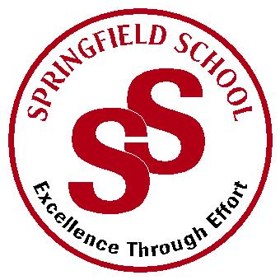
Springfield School
Crewe Green Road, Crewe, Cheshire CW1 5HS t: 01270 685446 f: 01270 258281

e: admin@springfield.cheshire.sch.uk www.springfield.cheshire.sch.uk

Headteacher: Lisa Hodgkison BA (Hons) | SEN SPECIALIST
 | SCHOOLS
2019/2020
Dear Parents and Guardians,
Re: Uniform
As well as enjoying a break with your children, parents will no doubt be looking forward to the annual trip to the shops to source uniform and school shoes. Before any of you embark on this please could I take this opportunity to remind you of some key parts of the policy.

Uniform is an important part of a school’s identity. It reinforces who we are as a community and helps allow students to feel pride in their school. It also ensures students are not put under any pressure because of the type of clothes they wear and all are treated equally. At Springfield we make our uniform suit our children needs and it can be adapted to ensure pupils are comfortable.

Primary Girls Primary Boys

Red polo shirts Red polo shirts
Grey skirt/pinafore dress/trousers Grey trousers
Red Sweatshirts Red sweatshirts
Grey or white socks or tights Grey or white socks
Black sensible shoes Black sensible shoes

Swimming/Hydrotherapy Costume/trunks plus one towel. (Swimming pads if applicable)
P.E. Trainers, red T-shirt, black shorts.

We now have a school uniform supplier www.gooddies.co.uk (or use the link on school website) that will produce school sweatshirts, polo shirts and T-shirts. These include the school name and logo. Please label all clothing

We also have uniform sales throughout the year, usually at our fundraising events.
Thank you for your continued support, and if you have any further queries please don’t hesitate to contact me.
Your Sincerely

Lisa Hodgkison
Headteacher

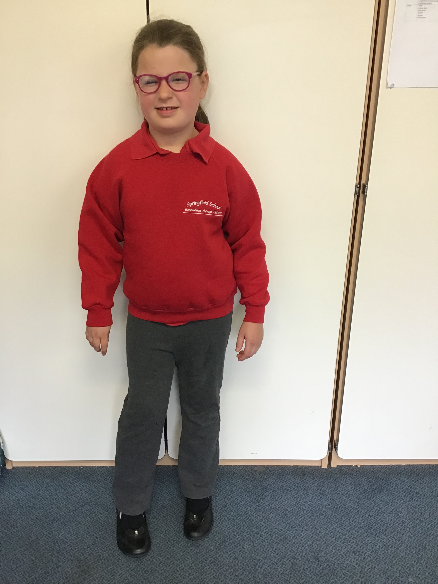
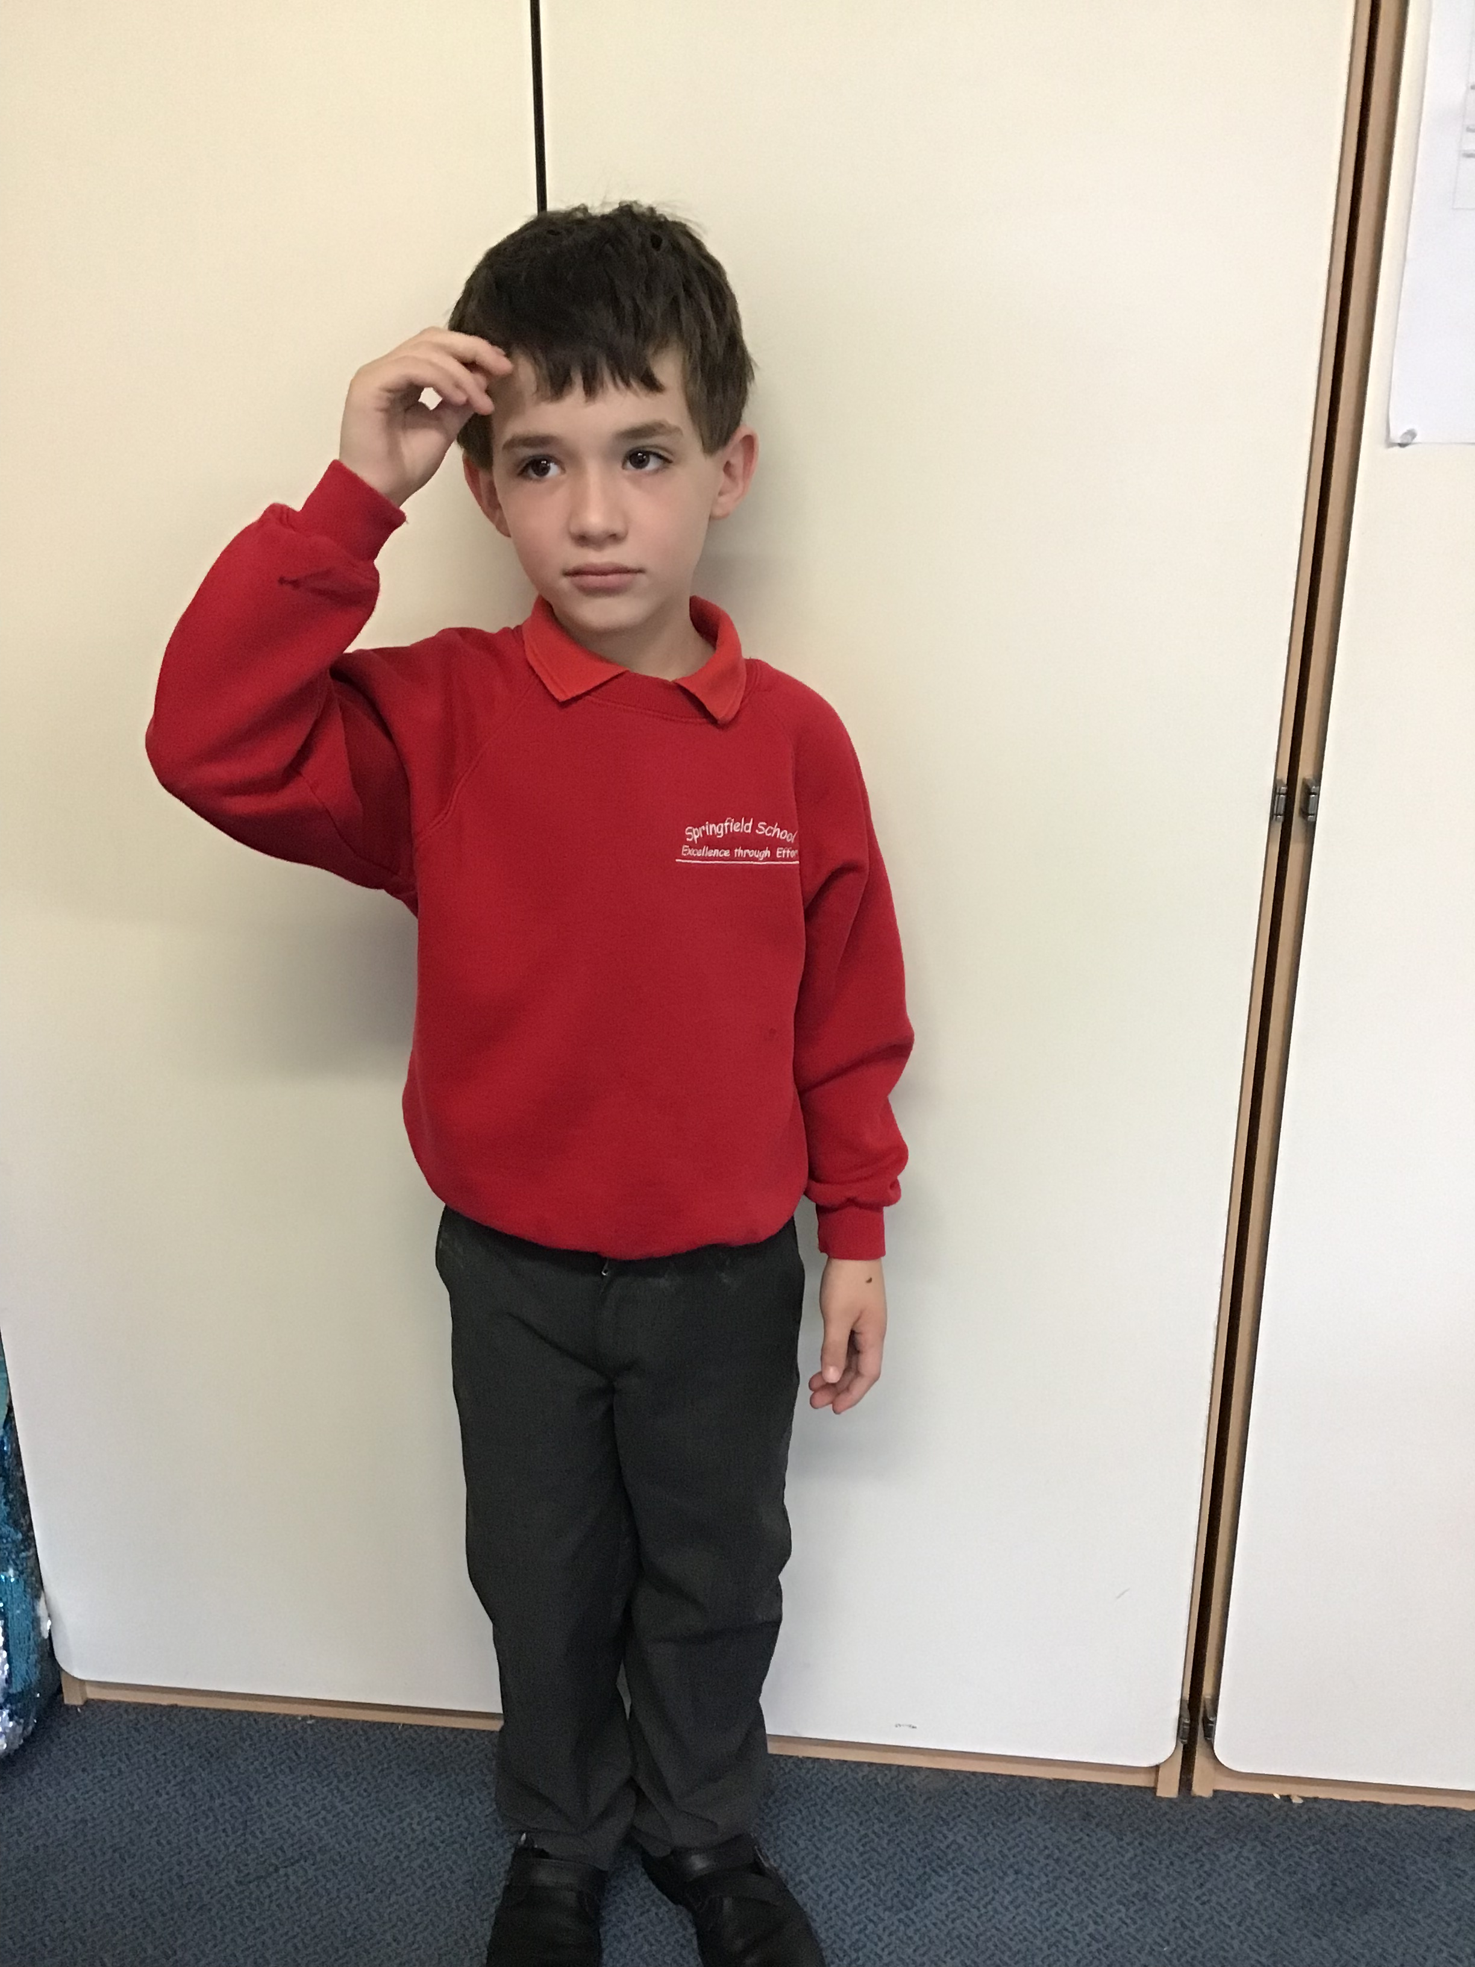

Providing an outstanding education for all our pupils

