An alternative curriculum

There is a growing understanding of the need to move away from the belief that one model of learning informs and justifies one model of teaching. For Pupils identified as having learning disabilities there is growing evidence about the importance of combining explicit instruction with guided problem solving and discussion in order to ensure transfer and generalisation of learning in subjects.
At Springfield school class 3HM have been exploring ways that the pupils in class can access the curriculum in a more appropriate way to meet their needs and develop their learning, equipping them for the skills needed for their life after school. Pupils with communication and interaction difficulties associated with severe and profound learning difficulties in association with ASD make up the class cohort. This group of Pupils tend to communicate at an early intentional or pre-intentional level. They adopt atypical, idiosyncratic, non-verbal or Augmentative methods of interacting with the world around them. Intervention aims include engendering social interaction with peers, using basic cognitive processes to develop information handling and management within the curriculum, removing obstacles to enable the pupil to participate in learning and the life of the school and wider community.
Pupils with Autistic Spectrum Disorders (ASD) are seen as displaying deficits in three key areas, atypical communication and social development, adherence to ritualistic behaviour, plus a resistance to change. Enhancing the communication of this class of individuals is fundamental to their participation and achievement, in all areas of the curriculum. So, in class we have moved away from task-centred, essentially behaviourist, incrementally designed approaches, towards a more social constructivist stance.
I would question the success of teaching of skills out of context and adherence to developmental checklists based on normally developing children since such methods discourage peer interaction and forms of experiential learning that would be both meaningful and relevant to the individual child concerned. I would advocate that a move to a more ‘sensory’ based approach being used in order to develop opportunities for exploration of and interaction with multi-sensory environments, much of which may be more easily accessed outside of the school environment/structure.
For pupils with ASD there are a wide variety of comprehensive and specific teaching approaches used and very few are used in isolation. Current methods employed in class include: applied behaviour analysis, Makaton signing and symbols, picture exchange communication system (PECS), sensory integration, social stories and treatment and education of autistic and communication handicapped Pupils (TEACCH).
Constructivist models of learning are those in which Pupils are seen as active participants in the processes of seeking out knowledge, making sense of their experiences and gaining intrinsic satisfaction from learning and solving problems. Constructivist learning is seen to be a transformative experience which opens up opportunities for further learning as Pupils gain greater depth of understanding and increasingly flexible ways of representing their knowledge and dealing with new information. Related to this approach is social constructivism or sociocultural theory. Here Pupils’ active role in learning is set in the context of their membership of social groups and communities, such as classrooms, schools or the wider community, which jointly create knowledge through their engagement in purposeful and valued activities.
Social constructivist is the principal theoretical perspective, focusing on ways of improving the quality of interaction, usually through active or participatory learning methods (small group work etc). This approach finds strong theoretical support in Vygotsky’s concept of the ‘zone of proximal development’ in which he states the belief that Pupils will progress to the next stage of expertise in a task through interacting with a more expert partner.
Social constructivist teaching takes a perspective on learning, viewing Pupils as active, curious learners who are motivated to join with other people to solve problems, develop knowledge and contribute to development of the learning community to which they belong. Learners benefit from the thoughtful attention and support of other people who provide expert knowledge and guidance which is gradually internalised to allow self-regulation (‘scaffolding’ and guided participation). For it is at this point that for Pupils with learning difficulties problems may arise, the motivation, the communication and interaction with other people are often obstacles to learning. The skill of the teacher is based on responsive teaching strategies typically focussing on different aspects of teacher-pupil interaction, ‘real’ problem solving and practical activities, pupil choice, and reflection on learning help pupils to progress and make sense of the world.
Our Alternative Curriculum
Through discussion with the Headteacher it has been decided that some pupils in 3HM will benefit from a bespoke curriculum based primarily offsite but, still working towards certification through ASDAN Transition Challenge. Transition Challenge offers a learner-centred, activity-based curriculum that can be undertaken with as much support as necessary. It has been developed for learners aged 14–16 with SEND, although it can be used with older age groups if appropriate.
There are two levels available, for pupils in 3HM the appropriate course is, Introduction and Progression: the activities in this programme cover the statutory programmes of study for the Key Stage 4 National Curriculum, along with activities to develop the skills required for adult living. ASDAN has produced a series of guidance documents showing how components of our programmes and qualifications can meet the four broad areas of need outlined in the SEND code of practice.
This strategy and approach focus on:
− The importance of providing opportunities for developing skills, in particular life skills
− For social interaction and access to the pupil’s local environment, including appropriate behaviour
− The importance of providing opportunities for developing skills that promote the pupil’s independence

Here are some photographs from some of our pupils on this bespoke curriculum:

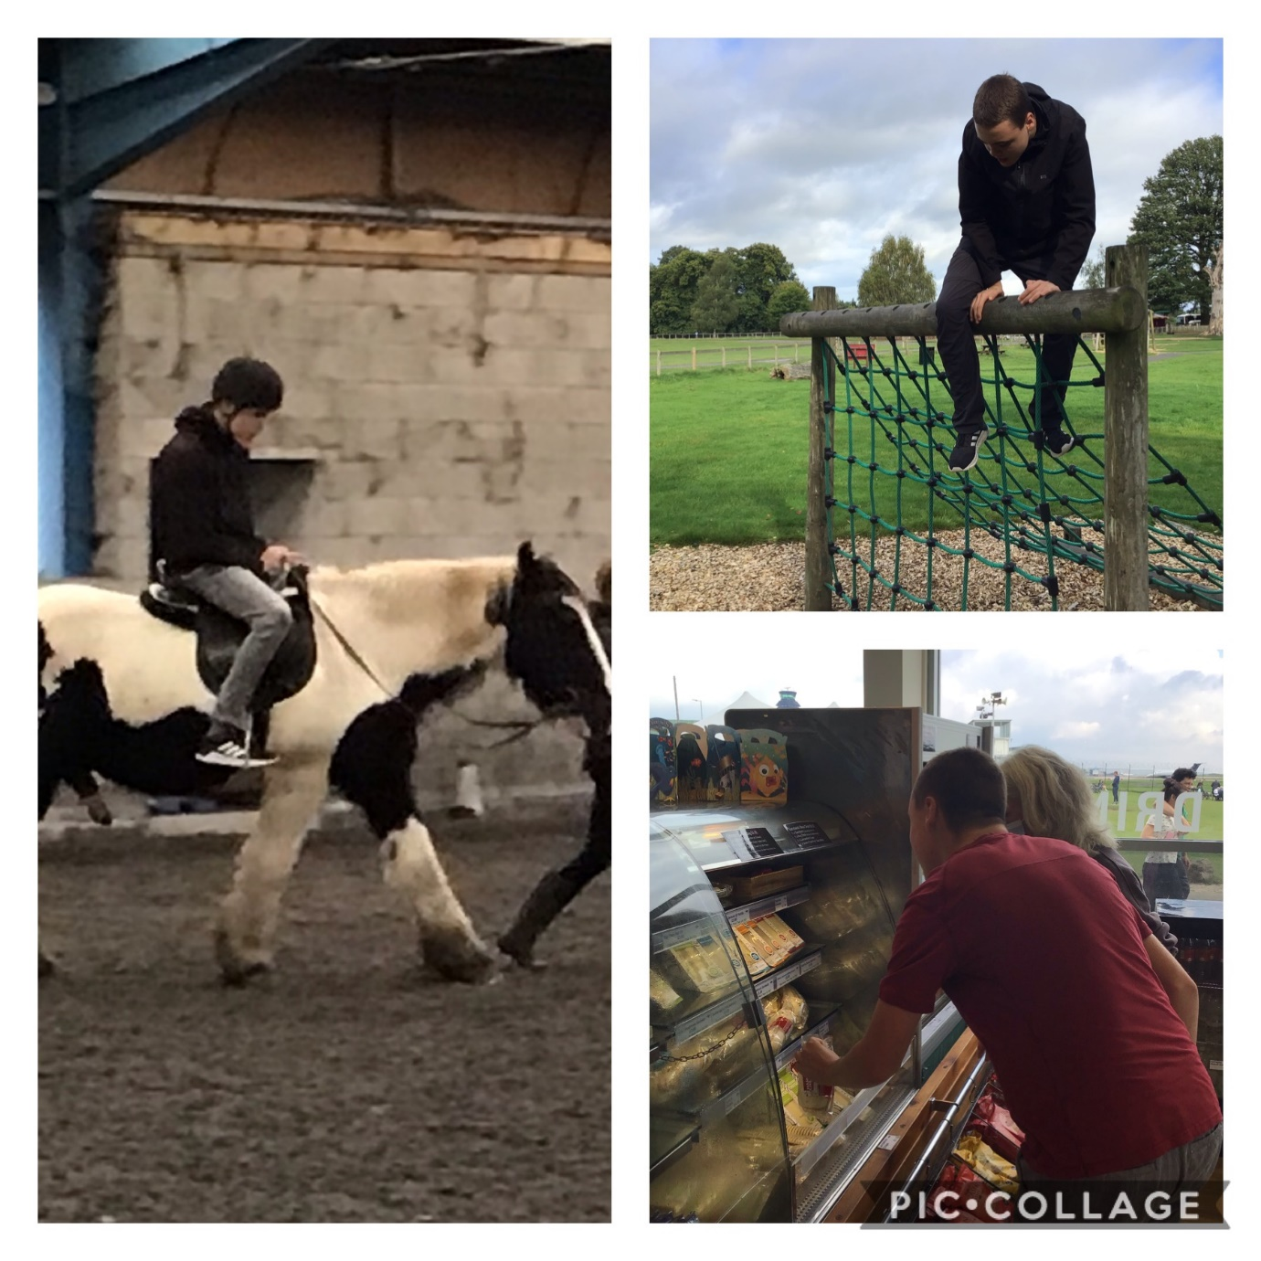
I am happiest when I’m out and about, I especially enjoy being in the countryside, walking and exploring. I am gaining skills in shopping, choosing my own lunch, and making decisions for myself.

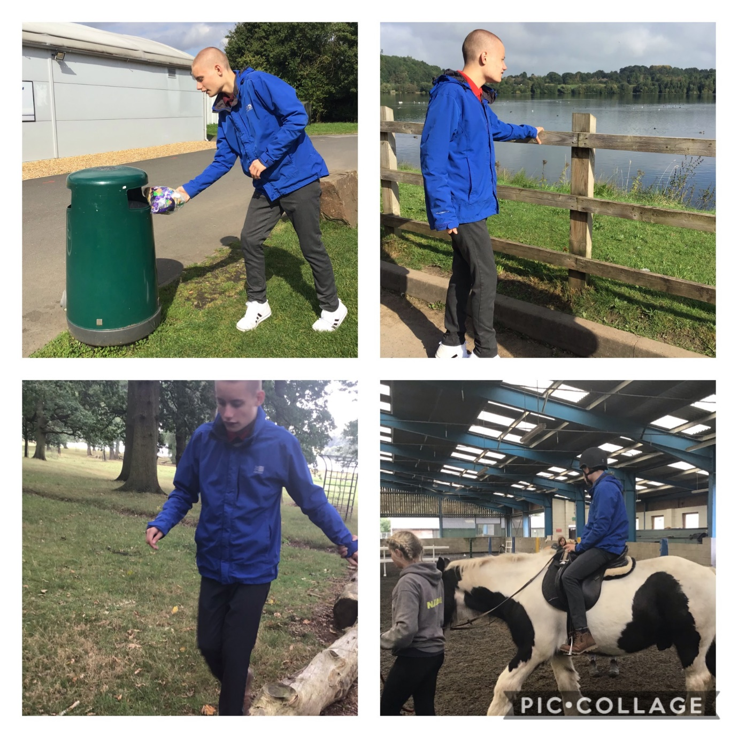
I enjoy walking in new environments, I am happy to explore, and just enjoy the freedom. Horse riding helps me to stay calm and focused.

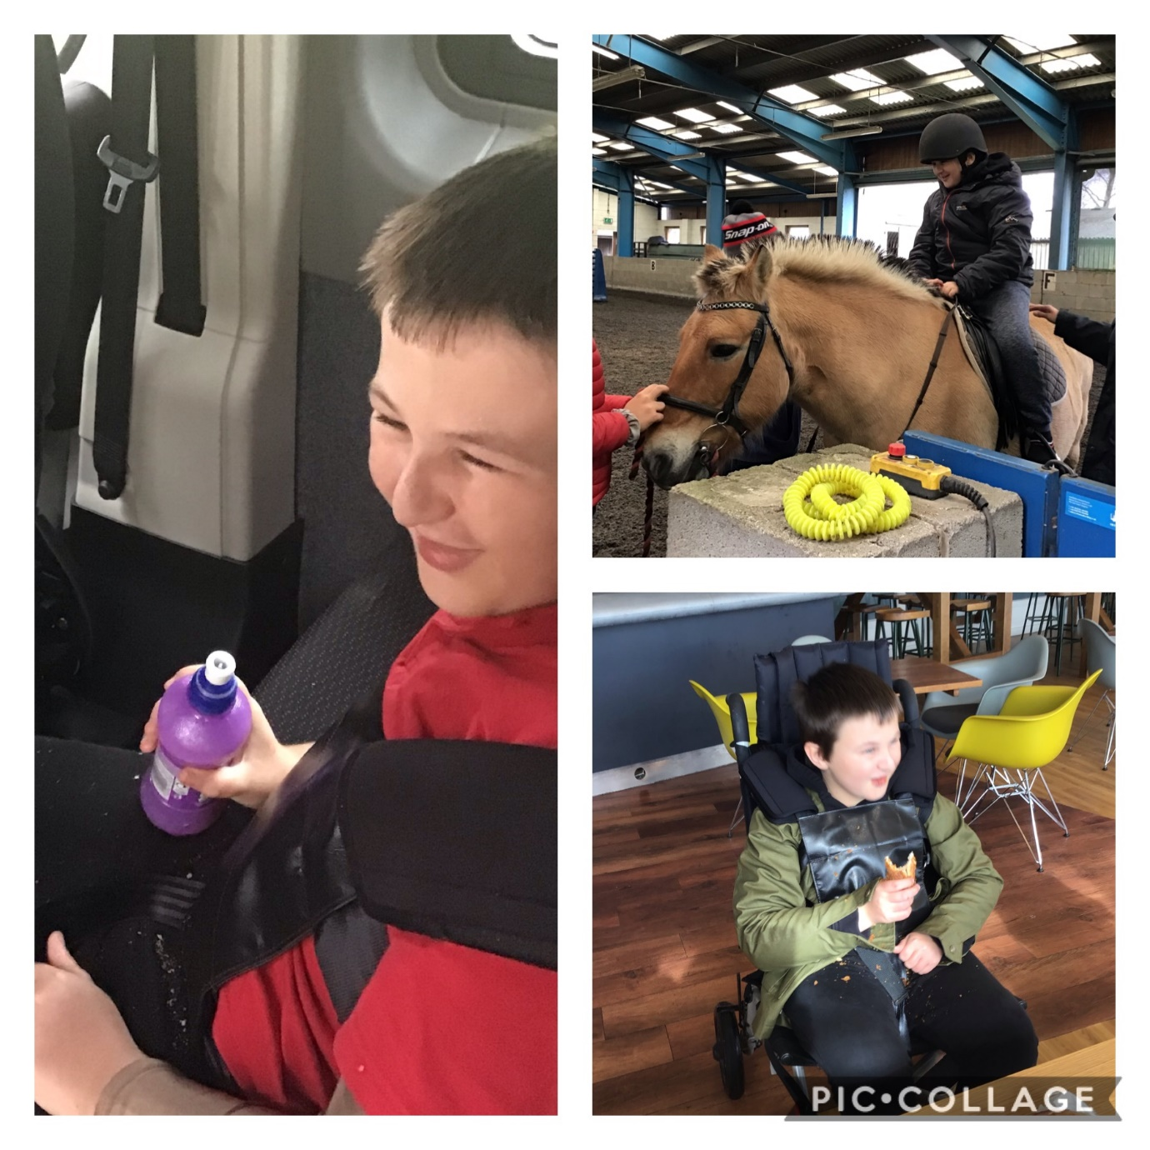
I have just started horse riding and I love it! I get very excited to see my horse, Peter.
I enjoy visiting cafes and am learning to sit patiently and wait for my food.

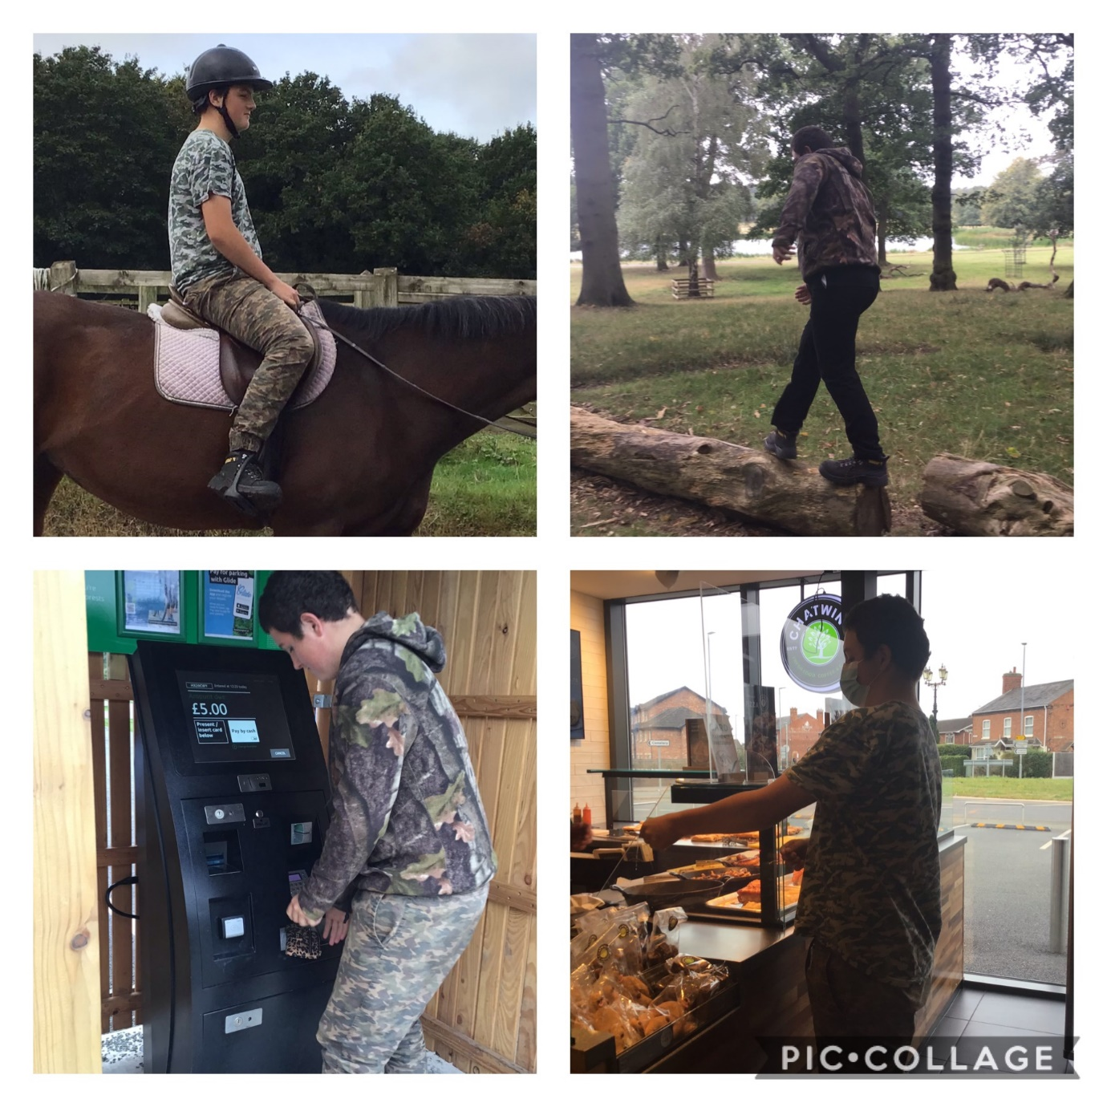
I love my visits out, I am gaining in confidence when faced with new situations. I can visit shops and cafes to choose my lunch and pay at the car parking machine at Delamere Forest.
Horse riding is my favourite activity, I am now able to trot for a short distance with the instructor beside me. Riding makes me feel calm and relaxed and I trust my horse, Ruby and the instructors to keep me safe.
Other visits include the airport, I had a short-wave radio for my birthday, and enjoy listening to air traffic control.

