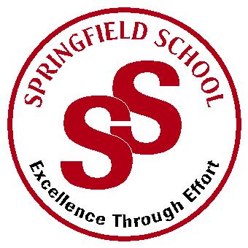**Springfield School**



Crewe Green Road, Crewe, Cheshire CW1 5HS t: 01270 685446 f: 01270 258281

e: admin@springfield.cheshire.sch.uk www.springfield.cheshire.sch.uk

|  |  |
| --- | --- |
| Headteacher: Lisa Hodgkison BA (Hons) | **SEN SPECIALIST** |
|  | **SCHOOLS** |



Friday, 11 September 2020

Dear Parents and Carers,

It has been such a wonderful week welcoming all our children back to school. We are all so proud of each and every one of them for settling in so well.

We say a warm welcome to all our new reception children and pupils that have joined school in other year groups.

You should have all received contact this week from your class teacher outlining daily routines and a plan for the next half term. All teachers regularly use e-schools for communication, if you have not already received your log on details please let us know and we will arrange this for you.

Our biggest challenge this week has been accommodating transport for both TSS and parents. Our arrangements for transport have had to change due to COVID, we thank everyone for their patience.

**Please see the confirmed transport times for parents below:**

* **Morning 9.15am – 9.30am**
* **Afternoon 3.15pm – 3.30pm**

**Illnesses**

Many thanks to those parents who have kept children at home with the beginnings of cold symptoms this week.

**For clarity –**

**Your child should be OK to come to school:**

* if your child develops cold-like symptoms.

**You may choose to exercise caution by keeping your child off school:**

* If they have had a rough night and have had insufficient sleep with cold symptoms.
* If they have also developed a sneeze and are spreading germs this way.

**Your child should stay off school:**

* If they have a high temperature alongside cold symptoms
* If they are exhibiting the key signs of the Covid virus – temperature, continuous cough loss of taste – in this case, you should arrange a Covid-19 test and inform school.

If your child is poorly during the school day, we may ask you to collect them.

If you do have any questions and concerns, please let us know at your earliest convenience and we will endeavour to support and help.

We are excited to see what achievements the first half tern will bring for all of our pupils. We will share further information when we resume our weekly newsletter from next Friday.

Wishing you all a lovely weekend.

Kind Regards

Lisa

L Hodgkison

Lisa Hodgkison

Headteacher