Parents Evening
You can book an appointment to see your child’s teacher(s) using the eSchools platform. You cannot do this from the app you will need an internet browser.
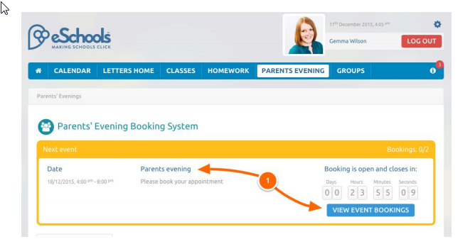
Click on the Parents Evening tab, then click on the title of the evening or View Event Bookings (1).

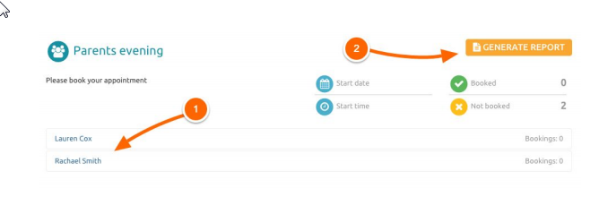
Once inside, you can book individual appointments for your children by clicking on their name (1). Once your bookings have been made you can generate a report, listing who you are due to see during the event (2).

Select an appropriate time from the available slots in the popup window. If a slot appears in grey, it has already been taken. Once you have selected an appointment time, it will appear in green. Save to return to the main Parents Evening screen.
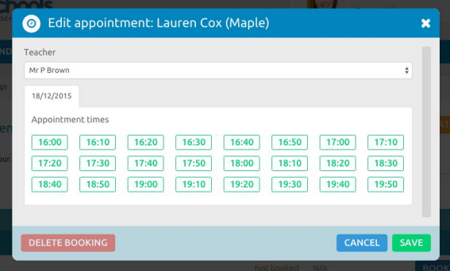

You can change your appointment at any time upto the date of the event, although some appoints might have already been taken by this stage!

