SPRINGFIELD SCHOOL POLICY
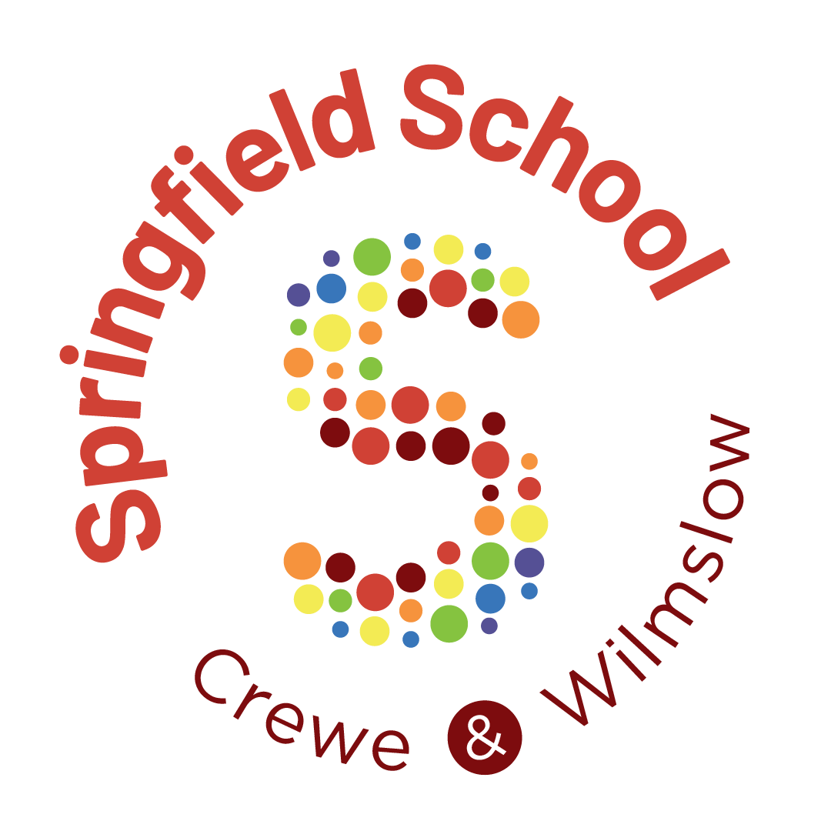

POLICY NAME: COMPLAINTS POLICY
NEXT REVIEW DATE: 01/09/2027

Last Reviewed – 01/10.2026

1. Our approach
1.1 We aim to resolve concerns promptly, fairly and respectfully. Parents and others should normally first speak with the class teacher or appropriate member of staff. We will provide help to complete forms and reasonable adjustments where needed.

2. What this procedure covers
2.1 This procedure covers complaints about the school that do not have a separate statutory or specialist route. Safeguarding concerns will be acted upon immediately under safeguarding arrangements.
2.2 Admissions, exclusions, employment matters and SEND Tribunal issues may require another route. We will explain this where relevant.

3. Stage 1 – Informal resolution
3.1 Everyday concerns should normally be raised with the relevant member of staff first. If the concern remains unresolved, please complete the Stage 1 – Headteacher Concern Form using the Microsoft Forms link below.
3.2 State what happened, when, the steps already taken and the outcome sought. The Headteacher or nominee will normally acknowledge or make contact within 10 working days and respond within a further 10 working days.
Stage 1 – Concern form for the Headteacher – Fill out form

4. Stage 2 – Formal complaint
4.1 If dissatisfied with the Stage 1 outcome, please complete the Stage 2 – Formal Complaint Form using the Microsoft Forms link below, normally within 10 working days. Identify precisely which Stage 1 points remain unresolved, why and what outcome is sought.
4.2 The Chair of Governors or an appropriately impartial nominee will normally acknowledge or make contact within 10 working days and respond within a further 10 working days.
Stage 2 – Formal Complaint Review – Fill out form

5. Keeping complaints focused
5.1 Please use the linked Microsoft Form for the relevant stage. The form will guide you to provide the information needed: the specific complaint points, relevant dates, steps already taken and the outcome sought.
5.2 Keep answers brief and focused; relevant evidence may be provided separately where necessary. We may ask for clarification before confirming the scope of an investigation.
5.3 We will offer assistance, alternative ways to submit a complaint and reasonable adjustments where appropriate. A complaint will not be dismissed solely because a person cannot use Microsoft Forms.
5.4 The school reserves the right to ask complainants to resubmit their complaint if it consists of generalized, unstructured, or computer-generated text that fails to clearly identify specific incidents or realistic outcomes. Additionally, lengthy background narratives, commentary, repetition, rhetorical questions or additional matters which do not constitute a clearly identifiable complaint point will not form part of the investigation.

6. Investigation and outcome
6.1 The school will decide what enquiries are reasonable and proportionate, including records to review and people to speak with.
6.2 The response will state whether each point is upheld, partly upheld or not upheld where a finding can be made, give brief reasons and identify any appropriate remedy.
6.3 Confidential staff, pupil and third-party information will not be shared through this procedure unless legally required. Employment or disciplinary outcomes remain confidential.

7. Stage 3 – Governor appeal
7.1 Escalation rule: After a Stage 1 response, a request for Stage 2 consideration should identify which original complaint points remain unresolved and why.
7.2 Later stages will normally focus on the points already considered, rather than restarting the investigation or adding unrelated issues.
7.1 To request an appeal, please complete the Stage 3 – Governor Appeal Form using the Microsoft Forms link below, normally within 10 working days of the Stage 2 outcome. Identify the decision or handling being challenged and why.
7.2 Three impartial governors with no prior involvement will normally review the appeal. A panel meeting will normally take place within 20 working days; the decision will normally follow within five working days.
Stage 3 – Governor Appeal Request – Fill out form

8. Determining the appropriate stage and progression
8.1 Complaints must normally follow the published stages. Complainants should complete the relevant Microsoft Form and receive a response at the earlier stage before requesting escalation.
8.2 Where earlier stages have been bypassed without the school’s agreement, the complaint will not be considered at the stage requested; the school may direct the complainant to the appropriate earlier stage.
8.3 Submission of a form does not automatically entitle a complainant to consideration at their requested stage. Springfield School will determine the appropriate stage from the information submitted, the nature of the complaint, previous correspondence and steps already taken.
8.4 The school may start at a later stage, move between stages or combine stages where reasonable and proportionate. The school will explain its decision in writing and preserve a fair and impartial final review where applicable.
8.5 Safeguarding concerns and matters requiring another statutory route will be handled appropriately without delay. Complaints about the Headteacher or governors will be referred to an impartial person rather than being required to go through the person complained about.

9. Timescales, conduct and closure
9.1 If a deadline cannot be met, we will explain why and give a revised date. We may set proportionate communication boundaries for persistent, abusive or repetitive contact without preventing genuinely new complaints or significant new evidence.
9.2 Completed complaints will not be reopened simply because the outcome is disputed. Records are kept securely; governors review complaint trends.

10. External review
10.1 After the school process, complainants may contact the Department for Education about alleged failure to follow the procedure or unlawful/unreasonable action. Ofsted does not normally resolve individual complaints.
10.2 Cheshire East Information, Advice and Support Service: 0300 123 5166; ias.service@cheshireeast.gov.uk.

Working days = the school is open to pupils.

