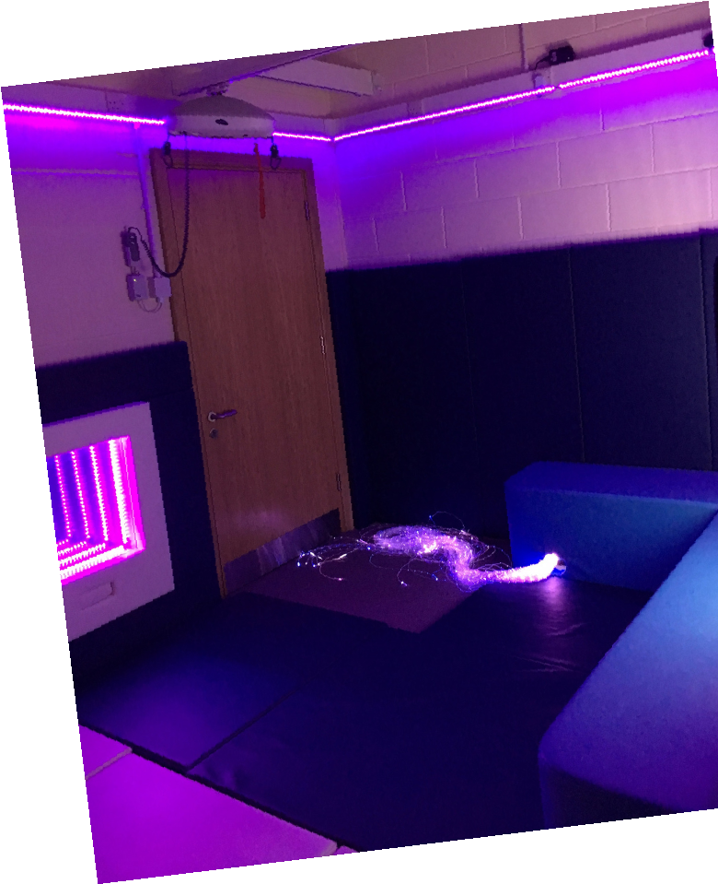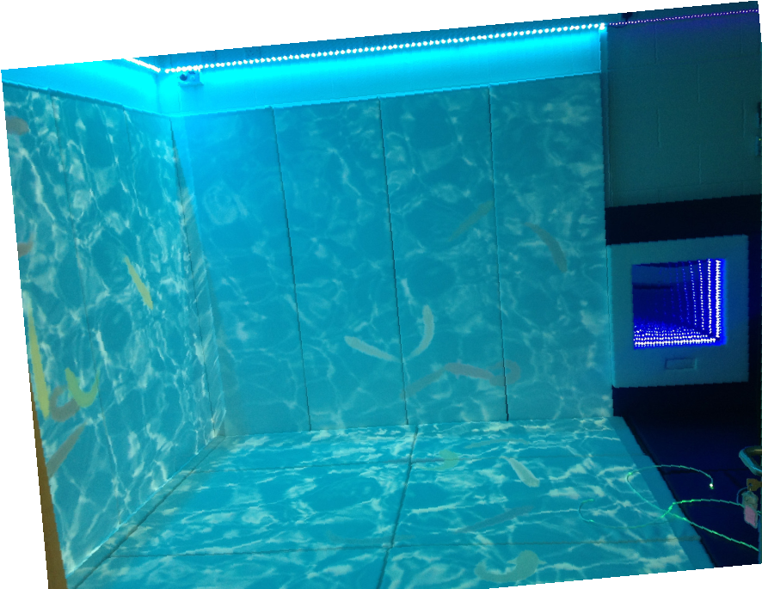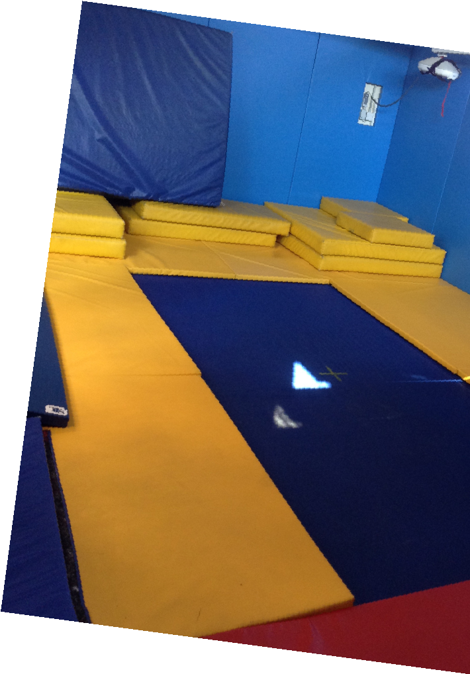

Springfield & Little Stars at

Monks Coppenhall Family Hub

This

stay and play session is aimed at

families with children with

additional needs from 0-4years

old.

Friday 1pm– 2.30pm (term time only)

at Monks Coppenhall Family Hub and Centre of Excellence for SEND,

Remer Street, Crewe, CW1 4LY

Meet other families

Messy and soft play

Sensory Room

oom

Sensory explore

Talk with other professionals.

Many more…...

We offer:

Booking is required so please either

phone or email

farida.begum@springfield.cheshire.sch.uk

tel: 01270

691900