
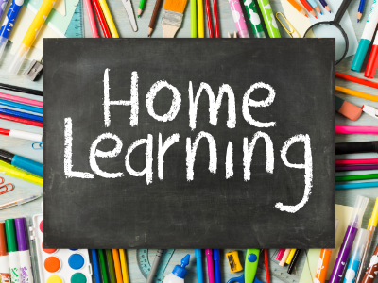

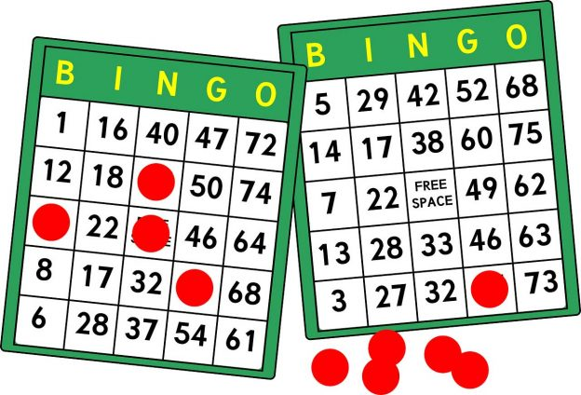
Please upload evidence to EfL.
If you are unable to then either:
- email your class teacher.
- send an eSchools message to your class teacher.
- or you can bring it in the old-fashioned way.
Thanks for your support in continued learning.
Numeracy:
Enjoy some animal number rhymes together – 5 little ducks, 5 little speckled frogs, 1, 2, 3, 4, 5 once I caught a fish alive…
Understanding the World and Expressive Arts and Design:
Explore outside and collect some natural materials…
Look for signs of Autumn – leaves changing, colder weather, conkers, leaves crunching under your feet!
Can you use the natural materials to create some Autumn art?
Independent Life Skills:
Can you get yourself dressed in the morning?
Can you brush your teeth or your hair?
How can you help make breakfast?
Can you find your shoes?

Free Choice
Show us something good you have learned at home or when out and about.
Personal, Social and Emotional Development:
Read or listen to “The Colour Monster?” Explore some colourful items with a parent/carer…
Physical Development:
Time to move!
Can you dance to your favourite song?
Can you help tidy up?
How about going for a little walk or exploring outside with an adult?
Sensory Regulation
What makes you feel calm and relaxed?
Try listening to or watching something calming. How about holding a fidget toy or something soft? You might want a fluffy or weighted blanket to help!
Literacy:
Enjoy stories at home, choose your favourites!
Complete some puzzles/jigsaws or practice your fine motor skills using a ribbon wand to dance or engaging in action songs together!

Communication and Language:
Can you make animal noises? How about listening to an animal song?
Can you move like different animals?
Identify your favourite animal…

