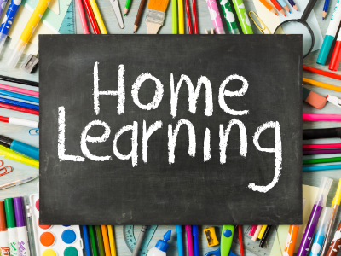

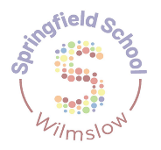

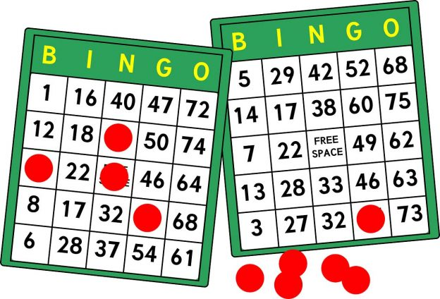
Maths:
Enjoy some of your favourite counting songs – can you join in or count how many?
Create your own pattern using natural items
Can you find shapes around your home?

Science:
With supervision, explore some plants – how do they smell, feel?
With a parent/carer, follow a nature trail or walk through a forest area – what do you see?
Please upload evidence to EfL.
If you are unable to then either:
- email your class teacher.
- send an eSchools message to your class teacher.
- or you can bring it in the old-fashioned way.
Thanks for your support in continued learning.
Sensory Regulation
Find a safe, cosy space or make a den. Take some of your favourite things with you – how do you feel?
Practice some movement songs with a partner such as ‘row, row, row your boat’ or ‘round and round the garden’
Independent Life Skills:
Can you get yourself dressed in the morning?
Can you brush your teeth or your hair?
How can you help make breakfast?
Can you find your shoes?

Physical Activity/Well-Being:
Create and complete an obstacle course!
Go to a playground with a parent or carer and enjoy swinging, spinning or sliding!
With a parent or carer, go for a walk in your favourite place…

Free Choice
Show us your favourite outdoor activity…
PSHE:
Request your favourite song to sing or dance to, then listen to a family member’s favourite song.
Play a turn taking game with a family member – such as jenga, pop up pirate, kerplunk!

Foundation Subjects:
Explore some different habitats with a parent/carer – which animals live there?
What’s the weather? Check the weather and find the right clothing for the day!
English:
Explore stories about the Rainforest or animals that live in the Rainforest…
Listen to some Rainforest sounds – what can you hear?

