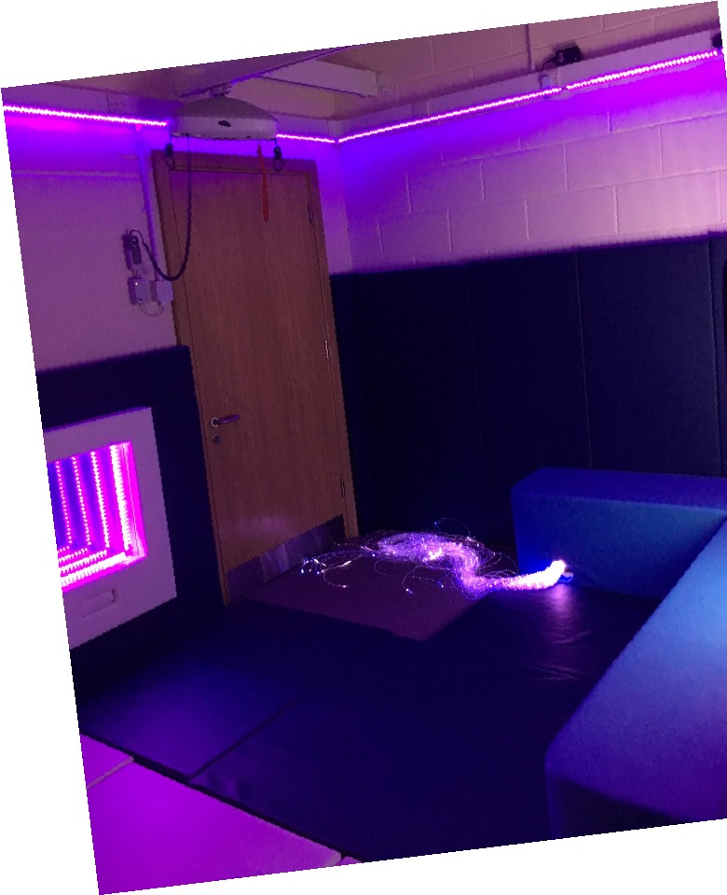
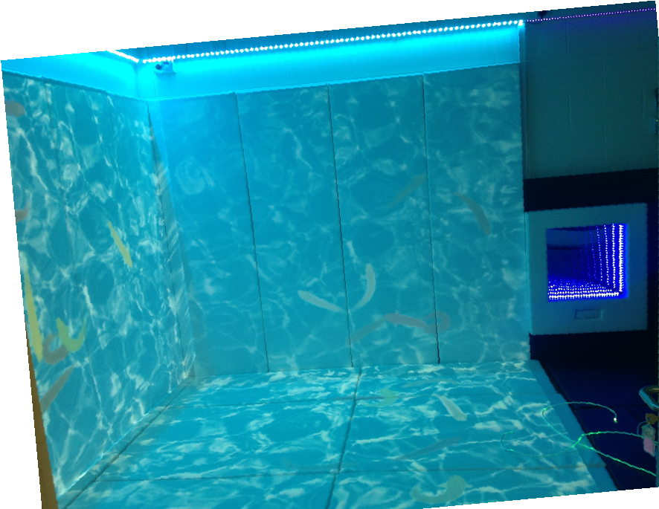

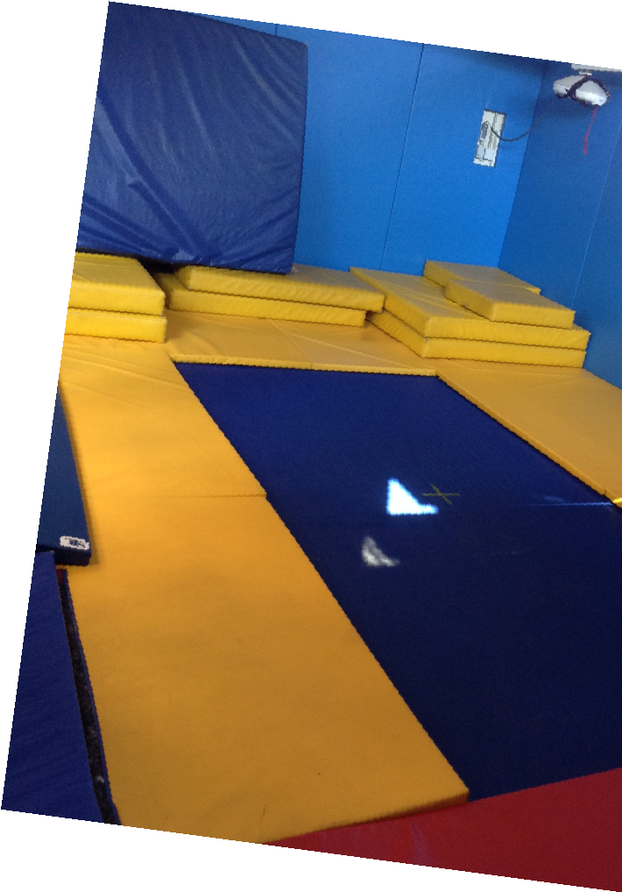


Springfield & Little Stars at
Monks Coppenhall Family Hub

This

stay and play session is aimed at
families with children with
additional needs from 0-4years
old.

Friday 1pm– 2.30pm (term time only)
at Monks Coppenhall Family Hub and Centre of Excellence for SEND,
Remer Street, Crewe, CW1 4LY

Meet other families
Messy and soft play

Sensory Room
oom
Sensory explore
Talk with other professionals.

Many more…...

We offer:

Booking is required so please either
phone or email
farida.begum@springfield.cheshire.sch.uk

tel: 01270
691900

