
Assessment Policy - Springfield School
September 2024

Basic Principles
Our curriculum is designed to secure, in students’ long-term memory, an ambitious body of developmentally appropriate essential knowledge for both academic and personal development. This is based on an adapted National Curriculum to meet pupils needs.
We recognise that it takes a long time for long-term memory to develop, and that repetition and a carefully sequenced curriculum is required in order for it to do so.
Learning is always appropriate and, over time, varied with the aim of building strong schemata in students’ long-term memory. Within one lesson the activities may look different for each student, appropriate to their individual needs.
At the heart of all learning is the child’s Education Health and Care Plan
Breadth of study (content)
Our curriculum meets the requirements for a broad and balanced curriculum based on the National Curriculum.
- We aim for our pupils to leave Springfield having received a broad and balanced curriculum and have access to a range of accreditations which promotes ‘Life after Springfield, Futures and Careers’ in allowing all pupils to make a positive step into society.
- This may be work, Supported Internship college, accessing a range of local services including supported or independent living.
- The EHCP is the driver for a personalised curriculum for our pupils.
In order to meet the needs of all of the learners we have Flexible Curriculum Pathways. Each of these core pathways are ambitious, carefully sequenced, well-considered and progressive. Each pathway has its own curriculum, but they are part of a greater learning continuum with each student getting a personalised curriculum to meet their academic and personal development needs.
There are some shared aspects, for example, PSHE, careers education, SMSC, Fundamental British Values, personal safety, health education and Preparation for Adulthood. Students can move between the pathways or experience elements of more than one.

The curriculum aims to provide motivating and relevant learning and development activities to maximise pupil engagement and support learning.
Personalised provision allows teachers to plan in direct response to a pupil’s individual needs and interests and taking account of their barriers to learning.
Pupils are well prepared for each phase of their education and transition in to meaningful, aspirational and independent adult life, well placed to make a positive contribution to life.

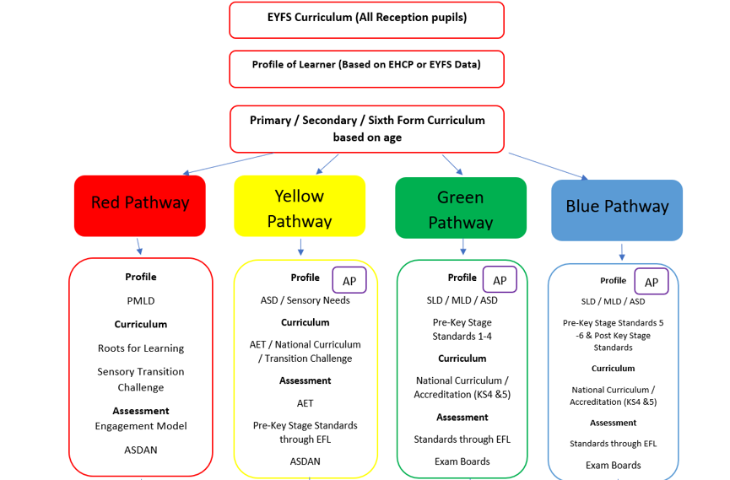

Progression
Our curriculum is based on flexible curriculum pathways comprising:
- Developmental Milestones as set out in the EHCP
- Academic Milestones as set out in the EHCP

All students are given ambitious and developmentally appropriate learning targets broken down directly from the EHCP.
Implementation
We understand that knowledge can be easily forgotten once an area of content is completed. To mitigate the likelihood of forgetting we:
- Have planned repetition and retrieval across lots of different contexts (yesterday, earlier in the day, last week and different environment)
- Reference new knowledge with prior knowledge which provides opportunity for recall.
- When appropriate use repetition and retrieval practice in a number of ways:
- Repetition and/or retrieval from previous year groups;
- Repetition and/or retrieval from previous topics;
- Repetition and/or retrieval from previous lessons;
- Repetition and/or retrieval from earlier in a lesson.

Knowledge is organised to provide students with an overview of the essential knowledge on the basis of a schema. Lessons are designed so students understand this knowledge.
- Systematic modelling forms the basis for the vast majority of teaching.
- Step-by step modelling
- Frequent re-visiting
- Frequent questioning
.
High quality evidence of students progress shows the essential knowledge they have been taught in each lesson through EFL.
Our curriculum is driven by specialist pedagogies and so, across the flexible curriculum pathways, teachers and support staff employ research-based techniques appropriate to the individual needs of students.
Spiritual, moral, social and cultural development is embedded in all aspects of personal and subject-specific development.
Impact
Monitoring Subjects:
Senior leaders monitor whether the intended curriculum is enacted by assessing:
- The extent to which the curriculum is implemented as planned; (LTP, MTP and weekly planning)
- Through direct observation, the extent to which teaching reflects our stated approaches (Subject Coordinators to observe their subject being taught)
- The curriculum team and heads of department monitor the effectiveness of the implemented curriculum by assessing:
  - The expertise of teachers in implementing the curriculum, providing support and training where necessary (lesson observations)
  - The students’ deliberate practice towards their milestones and the quality of evidence recorded by staff and/or students’ work. (EfL)
  - The extent to which students are remembering and knowing more as they progress through the curriculum (discussions with students)

Subject coordinators provide information to senior leaders about the above. In addition, they are supported in conducting a deep dive into their subject so they can see the strengths and areas for improvement in curriculum design. They produce subject evaluation for senior leaders based on their findings.

Measuring success
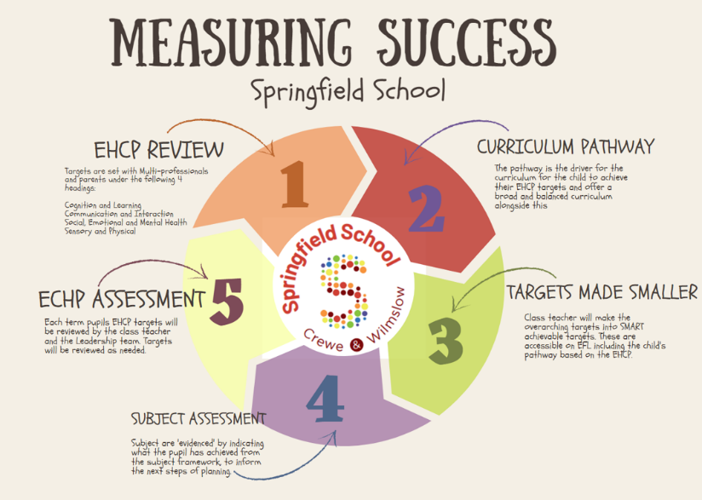
All children and young people progress at different rates, especially pupils with SEND. Children and young people and their needs are individual, and what is appropriate progress is therefore also individual. Success will mean different things for each child. Each child’s progress will be measured against appropriately challenging and individualised targets and learning outcomes.
At Springfield we expect that all children and young people will make the best possible progress from their individual starting points. We aim for our pupils to leave Springfield having received a broad and balanced curriculum and access to a range of accreditations which promotes ‘Life after Springfield, Futures and Careers’ in allowing all pupils to make a positive step into society. This may be work, college, accessing a range of local services including supported or unsupported living. The children or young person’s EHCP is the driver for a personalised curriculum for all of our pupils.

Pupils are assessed through a range of assessment methods these include:
- Classroom Observations,
- Learning Walks,
- Conversations,
- A Range Of Accreditations (KS5), EHCP Target Progress,
- Engagement Model,
- AET Standards,
- National Curriculum Assessment.
- Progress meetings take place termly with each teacher and their Line Manager.
- EHCP Meetings Take Place Annually To Review Success With Parents And Multi Agencies.
- EHCP targets are continually updated approved by Key Stage Leads.

Literacy and Numeracy for all pupils are assessed through the use of an assessment book using EFL this allows us to see specifically where gaps may occur in learning and interventions that need to be put in place.

At Springfield we use a whole range of strategies to ensure pupils are making progress and receiving a broad and balanced curriculum
We assess in 3 different ways at Springfield School to ensure progress is made.
Type of assessment | EHCP | Subject | Accreditation (Only where appropriate – Sixth Form, Internship and D of E)
 | Class Teacher | Class Teacher | Class Teacher
How the teacher assesses | Targets set at with multi professionals at Annual Review.  Targets are used as a basis for teaching reviewed daily by the class teacher.  Once a target is achieved the teacher creates the next small target. | To deliver the subjects within the timetables following:  LTP, MTP to produce weekly planning.  Complete EfL entries and assess pupils against the subject standards | To deliver the syllabus as set out by the exam board.  To ensure that a curriculum is taught alongside the subject.  To monitor progress against awarding body standards.
 | Subject Coordinator | Subject Coordinator | Subject Coordinator
How the Subject Co-ordinator measures progress in their subject. | Monitors the area linked closest to their Subject.  Cognition and Learning = English and Maths  Communication and Interaction = English / Communication  Social, Emotional, Mental Health = PSHE  Physical / Sensory = PE , AET | Monitor how their subject is delivered:  Sharing LTP and MTP  Assess staff who may need training.  Complete short learning walks of their subject being taught. | To ensure accreditation where appropriate fits into the curriculum and LTP, MTP and the subject progression map.  To support to ensure the curriculum fits around the accreditation.

 | Subject Leader / LT Member | Subject Leader / LT Member | Subject Leader / LT Member
How the Subject Leader /LT measures progress in their subject. | Monitor EHCP targets by:  - Classroom Observations  - Learning Walks  - Conversations  - Reviewing newly set targets.  - Progress meeting with class teacher. | Monitor Subjects by:  - EFL data (Core Subjects)  - Planning scrutiny  - Classroom Observations  - Learning Walks  - Conversations  - Progress meeting with subject coordinators | Monitor accreditation by:  - Assessing appropriateness  - Ensuring moderation and internal verification is complete.  - Ensuring exams are conducted in line with boards procedures.
Why we do it.. | To ensure each pupil is making progress against their individual targets set against the EHCP.  The subject coordinators will ensure alongside these targets a broad and balanced curriculum is being delivered.  Leadership members alongside class teachers will assess if the child is making good progress from their starting point. | The data from EfL shows any areas of concern or lack of progress made. Gaps in the framework would be easily identifiable.  Pupils who are not making progress in subject areas would be seen through this data set. | To ensure accreditation builds on prior knowledge and matches future aspirations for learners in the Sixth Form.
When we do it.. | - Targets regularly reviewed.  - Termly progress meeting with LT  - Learning walks termly | - SC Learning walks termly  - LT learning walks termly  - Subject Team meetings termly | - Annual Review of Accreditation  - Moderation in line with the exam boards expectations

EHCP Data
Data meetings are held termly with the class teacher and line manager as part of the school’s performance management process.
During this meeting each pupil’s progress is discussed in relation to their own individual starting point and the progress they have made against their EHCP targets. Pupils are identified as being on target or making smaller steps of progress.
Judgements are made in a professional capacity based on historic data that the school holds and understands how pupils with cognition and learning barriers learn best.
What do we mean by a pupil on target:
- Challenging long term targets have been set with multi professionals inline with the EHCP process.
- Teachers and class teams have broken the longer term done into smaller targets using a range of frameworks appropriate to the induvial pupil.
- Targets are approved by Key Stage leads ensuring they are challenging and appropriate.
- Targets are delivered through all parts of the school day including but not exclusive to curriculum lessons.
- Progress is recorded against the target through a personal learning record which shows a minimum of 3 distinct stages.
- Progress is analysed by DHT’s and HT’s and termly discussions are held to review each child’s progress to ensure it is in line with their own personal journey based on previous and historical data.
- If a child is making smaller steps of progress reasons will be outlined and recorded on the feedback documentation.

Reporting to Parents
Evidence for learning allows us to give parents access to their own child’s learning journey. They can see records, observations and reports of their child. We encourage parents to make comments and to upload their own evidence taken at home to celebrate achievements so that an open dialogue can be had about their child’s personal achievements.
Reports to parents are given verbally at parents’ evenings twice a year in the Autumn and Summer term. This is a chance for the parents to discuss their child’s achievements so far and discuss their next steps.
A comprehensive written report is provided each year for the EHCP annual review meeting, and this is where new / existing targets are agreed and evaluated.
Parents are invited to discuss their child’s progress informally at any time throughout the school year and are welcome to see their child’s work and discuss matters arising with the class teacher at a mutually convenient time either by phone or in person.
Data is statutorily reported annually to the Local Authority/ Department for Education (DfE) and parents at the end of: -
- Reception Bassline Assessment
- EYFS
- Year 1 Phonics Screening Test / Retaken in Year 2 if not met standard
- Year 2
- Year 6

Because our pupils are not working at age-expected levels for the test we are able to dis-apply our pupils from the reception baseline, KS1, KS2 SATS’s and Phonics

Red Pathway
PMLD Pre KSS
Blue Pathway
SLD / MLD / ASD
Standard 5-9

Pupils are assessed through the progress made against the engagement model.
Pupils are assessed against the progress made towards their End of Key Stage targets taken from their EHCP.
All Data Collected through EFL with an individual learning journey.
Pupils are assessed through the progress made against the AET standards.
Pupils are assessed against the progress made towards their End of Key Stage targets taken from their EHCP.
All Data Collected through EFL with an individual learning journey.

Pupils are assessed through the progress made against the standards from the National Curriculum.
Pupils are assessed against the progress made towards their End of Key Stage targets taken from their EHCP.
All Data Collected through EFL with an individual learning journey.

Pupils are assessed through the progress made against the standards from the National Curriculum.
Pupils are assessed against the progress made towards their End of Key Stage targets taken from their EHCP.
All Data Collected through EFL with an individual learning journey.

Yellow Pathway
ASD / Sensory Needs
Green Pathway
SLD / MLD / ASD
Bridge 1, – Standard 1-4

Literacy and Numeracy are assessed through assessment books these focus on Phonics, reading, writing speaking and listening and numeracy strands.
Through EHCP we measure success through the progress against targets set in the areas of Communication and Interaction, Cognition and Learning, Social, Emotional Mental Health and Sensory and Physical.

