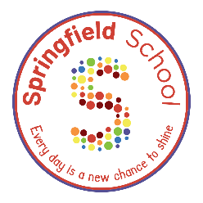
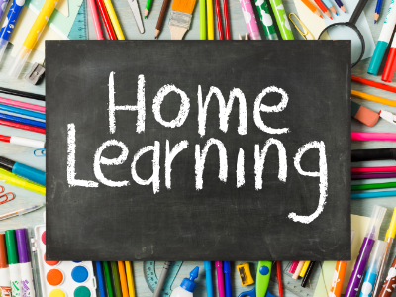

Bingo board!
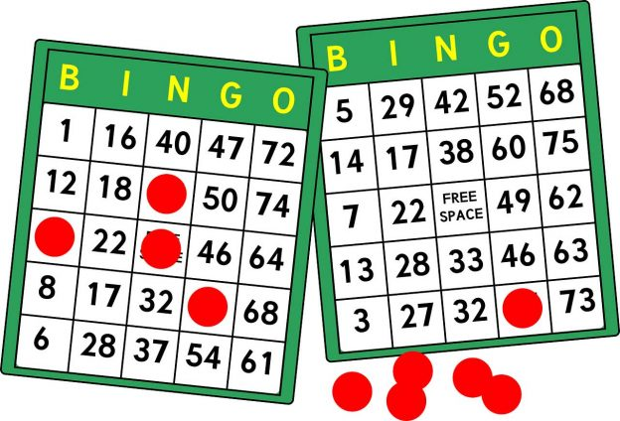
English:
Writing Transcription:
Can you imitate marks made in sensory materials?
E.g., sprinkle some flour in a baking tray and copy the marks (line/circle/spiral) an adult makes in the tray.

Physical Education:
Throwing and Catching:
Can you throw a ball or beanbag into a target?
Can you move the target further away and still get the ball/beanbag to go in?
PSHE:
Relationships/Play Skills:
Can you share your toys and play with a member of your family for 10 minutes?

Life Skills:
Can you sit with your family to eat your dinner and try a new food?
Life Skills:
Can you brush your teeth every morning before school with some help from a grown up?
Maths:
Pattern:
Ask your adult to create a simple pattern of toys or household objects e.g., spoon, cup, spoon, cup.
Can you finish the pattern?
Can you make your own pattern?
Please upload evidence to EfL.
If you are unable to then either:
- email your class teacher.
- send an eSchools message to your class teacher.
- or you can bring it in the old-fashioned way.
Thanks for your support in continued learning.
Communication:
Can you use your preferred method of communication to ask for a toy/device you would like to play with?
PECS/iPad/Communication Mat/Signing/Speech.

Free Choice
Show us something good you have learned at home or when out and about.
Science:
Sounds:
Can you go on an Autumn listening walk?
Use your communication mat to identify the different sounds you can hear.

