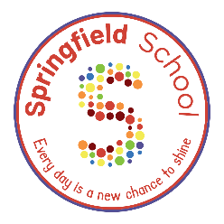
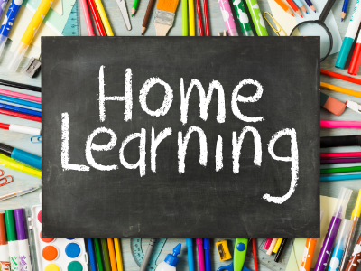

Bingo board!
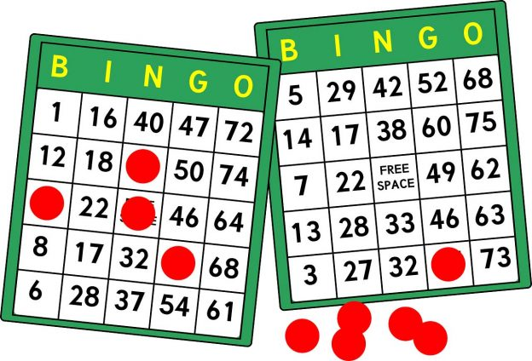
English:
Writing Transcription:
Can you write out your family shopping list?
Add some pictures once you’ve finished!
Phonics/Reading:
Can you read your reading book to a family member?
When you have finished reading, can you retell what happened in the story?

Physical Education:
Throwing and Catching:
Can you throw and catch a ball 10 times with a family member without dropping it?
Can you count how many times you can throw and catch a ball in 2 minutes?
PSHE:
Relationships/Play Skills:
Can you play a simple game with someone in your family?
Can you cheer them on and celebrate if they win?

Life Skills:
Can you set the table for dinnertime and then sit with your family for your dinner?
Can you ask a family member a question about their day?
Life Skills:
Can you brush your own teeth every morning before school?
Maths:
Pattern:
Ask your adult to create a pattern using 3 toys or household objects e.g., spoon, cup, fork, spoon, cup, fork.
Can you finish the pattern?
Can you make your own pattern using 3 items?
Please upload evidence to EfL.
If you are unable to then either:
- email your class teacher.
- send an eSchools message to your class teacher.
- or you can bring it in the old-fashioned way.
Thanks for your support in continued learning.

Free Choice
Show us something good you have learned at home or when out and about.
Science:
Electricity:
With an adult, can you go on a hunt to find items that use electricity in your house?
You could make a list by writing or drawing the items you find!

