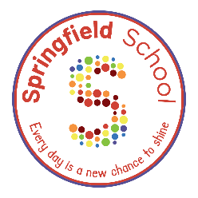
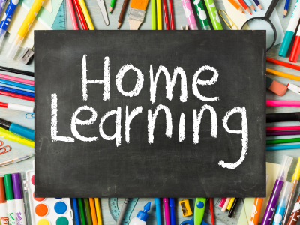

Bingo board!
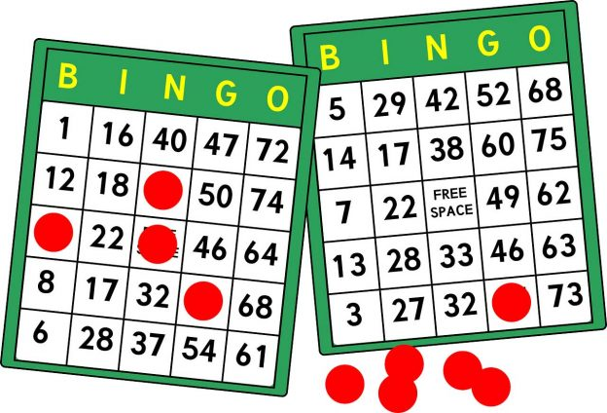
Science:
Sound:
Can you create a kitchen band? Use different kitchen items to make loud and quiet sounds.
(Loud and quiet symbols given on communication mat)
English:
Writing Transcription:
Can you make lines and circles in sensory materials?
E.g., sprinkle some flour in a baking tray and use fingers to make lines/circles.
Life Skills:
Can you sit with your family to eat your dinner?
PSHE:
Relationships/Play Skills:
Can you share a sensory play activity (e.g., water play) with someone in your family?
Life Skills:
Can you let an adult brush your teeth every morning before school and then have a go yourself?
Maths:
Colour:
Can you go on a colour hunt and gather toys/household objects of 3 different colours?
Can you sort the objects you found by colour?
Please upload evidence to EfL.
If you are unable to then either:
- email your class teacher.
- send an eSchools message to your class teacher.
- or you can bring it in the old-fashioned way.
Thanks for your support in continued learning.
Physical Education:
Sensory Regulation-
- Go on the trampoline.
- Go on a bike/scooter.
- Make a pile of cushions to jump into!
- Do some rocking and spinning to music.
Communication:
Can you use your preferred method of communication to ask for a toy/device you would like to play with?
Object of reference/ PECS/iPad/Communication Mat/Signing/Speech.

Free Choice
Show us something good you have learned at home or when out and about.

