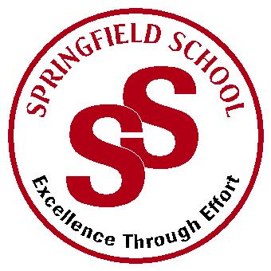**Springfield School**



Crewe Green Road, Crewe, Cheshire CW1 5HS t: 01270 685446 f: 01270 258281

e: admin@springfield.cheshire.sch.uk www.springfield.cheshire.sch.uk

|  |  |
| --- | --- |
| Headteacher: Lisa Hodgkison BA (Hons) | **SEN SPECIALIST** |
|  | **SCHOOLS** |



Friday, 23 October 2020

Dear Parents and Carers,

As half term has arrived, I wanted to write to you to express our sincere thanks to all our parents and pupils for such wonderful support since September.

Our children have amazed us, as they always do with their resilience, determination, and happy smiling faces on their return to school. Springfield school has regained its ‘buzz’ and sense of community again which is wonderful. This couldn’t have been achieved without the support of all our community and obviously our fantastic staff teams.

Although this half term has been positive in terms of only having to close two bubbles however, we need to mindful that we are now approaching winter and the higher alert level of Tier 2. Our aim is to keep the school as functional as we possibly can throughout this difficult period.

If during the holiday your child becomes **unwell and tests positive for COVID** please email [head@springfield.cheshire.sch.uk](mailto:head@springfield.cheshire.sch.uk) it is important that we have this information immediately as there may be implications for other staff and pupils.

We hope that your children all enjoy some well-deserved down time next week. **School will reopen on Tuesday 3rd November.**

If you do have any questions and concerns, please let us know at your earliest convenience and we will endeavour to support and help.

Kind Regards

Lisa

Lisa Hodgkison

Headteacher