December 2016

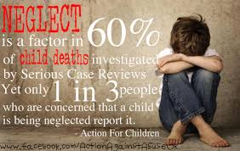
“Neglect: is the persistent failure to meet a child’s basic physical and/or psychological needs, likely to result in the serious impairment of the child’s health or development. Neglect may occur during pregnancy as a result of maternal substance abuse. Once a child is born, neglect may involve a parent or carer failing to: provide adequate food, clothing and shelter (including exclusion from home or abandonment); protect a child from physical and emotional harm or danger; ensure adequate supervision (including the use of inadequate care-givers); or ensure access to appropriate medical care or treatment. It may also include neglect of, or unresponsiveness to, a child’s basic emotional needs.” Keeping Children Safe in Education 2016

Neglect can happen over a period of time, but can also be a one-off event. There are different types of neglect: Physical, Medical, Emotional and Educational. Incidents often don’t meet social care or criminal thresholds; it is the cumulative effect that is most impactful. A child who is neglected will often suffer from other abuse as well, both inside and outside of the home.

The effects of neglect:
Neglect can have serious and long-lasting effects. Not only will it make a child’s life miserable but it can affect all aspects of their development and future relationships.

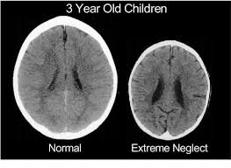
Effects can be anything from affecting early brain development, language delay, physical injuries from accidents, low self-esteem, poor school attendance, to self-harm and suicide attempts.

In the very worst cases a child dies from malnutrition or being denied the care they need. In some other cases it can cause permanent disabilities.

Though neglect can affect any child, its impact particularly applies to infants and very young children who, among all the age groups, are at the highest risk of death and/or incurring lasting mental and physical damage.
From: ‘Child Neglect Be Professionally Curious!’ National Multi Agency Child Neglect Strategic Work Group.

What can schools do?
Schools should be aware of the warning signs and symptoms of child neglect which vary from child to child. By understanding these indicators we can respond to problems as early as possible and provide the right support and services for the child and their family.
Things to be aware of:
- they seem like they haven’t washed, are dirty/smelly, their clothes seem dirty
- they are hungry or asking for other people’s food
- they often come to school with no lunch money or packed lunch
- their parents don’t seem to know where they are or what they are doing
- they often don’t turn up for school, or they arrive late
- they don’t seem to have many friends
- they get sent to school even when they are really unwell
- they are not growing as they should
- they are showing signs of slow development
- they have an unusual relationship with a parent e.g. parents show a lack of compassion, or the child may seem anxious not to upset the parent and even appear to be afraid of them
- they may appear to be nervous, unusually fussy or very withdrawn. Some children may also copy or act out what they have experienced at home, such as violence or sexual activity.

Adolescent neglect:
Whilst neglect is usually an act of omission, adolescent neglect can be a deliberate act where young people may be abandoned by parents or forced to leave home. Recent research has highlighted that the vulnerability of adolescents is often overlooked because they are considered to be already adult or thought to be resilient. A survey commissioned by the Children’s society was published in 2016 Understanding Adolescent Neglect: Troubled Teens. A study of the links between parenting and adolescent neglect - Youth Justice Resource Hub; this study
found that one in seven 14 and 15-year-olds had experienced at least one form of neglectful parenting, the equivalent of three students in every year 10 classroom.
Neglect can include parents failing to monitor their child’s activities outside the home, not making sure they get healthcare when they need it, not taking an interest in their education or failing to provide emotional support by helping them with problems or offering encouragement.

Emotional and supervisory neglect were the joint most common forms reported by year 10 pupils and the former was associated with teenagers being more likely to engage in risky behaviour.

Those who said they had experienced emotional neglect were more than twice as likely than their peers to have got drunk recently, nearly three times as likely to have smoked and more than twice as likely to have skipped lessons.

Neglected teenagers were also significantly more likely to be dissatisfied with their lives, pessimistic about their futures and lacking confidence in their abilities.

Adolescent neglect is more common amongst young people with disabilities, Cared for young people, and young carers. It can lead to a range of poor outcomes for the young people, for example poor physical health, anxiety, drug and alcohol abuse as well as early sexual activity. Neglected adolescents are more likely to run away from home and experience sexual exploitation.

The neglected child in school may:
- have gaps in their education
- have general learning disabilities
- have poor problem solving abilities
- have poor reading, writing and maths skills
- have few friends
- have little confidence, be disruptive or overactive in class
- be desperate for attention or desperate to keep out of the ‘limelight’
- try too hard
- blame themselves for a wide range of issues.
(Adapted from Aggleton, Dennison and Warwick 2010)

Schools can support neglected children in the following ways:
- ensure their inclusion in learning activities
- recognise and reward the work they do.
- adapt school systems for managing disruptive behaviour
- identify gaps and find ways to meet their learning needs/ learning disabilities
- ensure they experience success across the curriculum and across activities
- promote positive teacher/ child and child/ child relationships
- ensure that there is a mixture of learning experiences
- ensure that they are and feel welcome in school.
- provide them with equipment from pencil and paper to PE clothes.
- include health and wellbeing in the curriculum.
- work closely with other services

Where you become aware of neglect then ensure that you act on these concerns:

- Gather the 24 hour lived experience of the child
- Complete a copy of the Cheshire East Neglect Screening Tool http://www.cheshireeastlscb.org.uk/professionals/neglect.aspx
- Consult with ChECS.

If you have concerns that a child is at risk you should contact Cheshire East Consultation Service (ChECS) and/or Cheshire East Police without delay:

ChECS: 0300 123 5012
Cheshire East Police: 101 or in urgent cases dial 999

Sources of support and advice:
http://www.cheshireeastlscb.org.uk/professionals/neglect.aspx

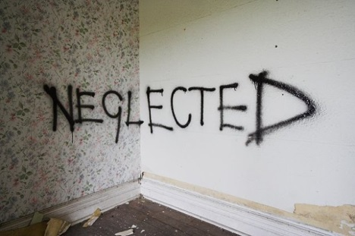
www.childline.org.uk/Neglect

Child neglect | NSPCC

Thriving-communities neglect report

Resources:
Neglect: Leanne's story | Childline

Wants and Needs (U Tube)

https://www.gov.uk/government/collections/childhood-neglect-training-resources

If you have you have concerns: ACT NOW!

