**Disability Positive Short Breaks offer**

**Buzz Youth Group**

Youth group for disabled young people aged 12-18 years (up to 18th Birthday)

Thursday 6.30-8.00 term time and daytime during school holidays

Crewe (Lifestyle Centre) and Macclesfield (Kings School)

Alternate weeks provision in each area

Fully accessible provision and 1-1 will be provided for personal care, behaviour and medical requirements

Registration is required before attendance

Waiting list may be in operation

Contact [Helen@disabilitypositive.org](mailto:Helen@disabilitypositive.org) for further information or to submit the attached request for services form.

**Duke of Edinburgh Award Programme**

Bronze Award for 14-18 years

Macclesfield base but open to any young person wishing to join

Monthly support sessions on third Saturday of the month : June-January (Kings School)

24 hour residential will take place January-May

Fully accessible provision and 1-1 will be provided for personal care, behaviour and medical requirements

Registration is required before attendance

Waiting list may be in operation

Contact [Helen@disabilitypositive.org](mailto:Helen@disabilitypositive.org) for further information or to submit the attached request for services form.

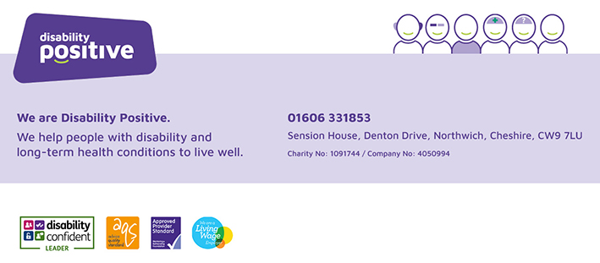

Community Engagement Team   
Request for Services

|  |
| --- |
| **Name of Young Person/Adult** |
|  |
| **Address** |
|  |
| **Date of Birth of Young Person/Adult** |
|  |
| **Name of Parent/Carer if appropriate** |
|  |
|  |
| **Email contact for family/adult**  **This is our preferred method of contact – if no email address please advise below and provide an alternative contact method** |
|  |
| **Disability / Diagnosis**  **Please give as much detail as possible** |
|  |
| **Request made by** |
| **Name**  **Organisation**  **Contact Number** |

|  |
| --- |
|  |
| **Signature of young person/family/adult to confirm consent for referral** |
|  |

|  |
| --- |
| **Request Details** |

|  |  |
| --- | --- |
| **Buzz Youth Activity Group 5-18 years (Cheshire West)**   * **Ellesmere Port** * **Northwich** * **Neston** * **Lifeskills** * **Weekend Group**   **Buzz Youth Activity Group 12-18 years (Cheshire East)**   * **Crewe (12-18)** * **Macclesfield (12-18)** * **Duke of Edinburgh (14-18)** |  |
| **Good Company 18+**   * **Weekly (Cheshire West)** |  |
| **Please give details of anything we would need to know before visiting the child/young person/adult including any assessed risk** |  |

**Please note the request for services may be returned if information is not completed in full.**

**Please return to:**

**Helen Webb, Community Engagement Team Administrator ,**

**Sension House, Denton Drive, Northwich, Cheshire, CW9 7LU**

**Tel: 01606 331853 or Email:** [**helen@disabilitypositive.org**](mailto:helen@disabilitypositive.org)

**Internal use only**

**Date referral received -------------------------**

**Received by ……………………..**