**Springfield School**

**Safeguarding Champions**

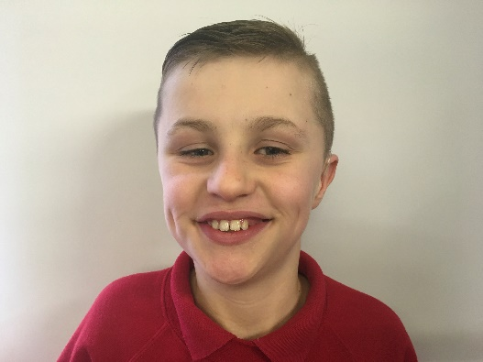

Oliver Highfield

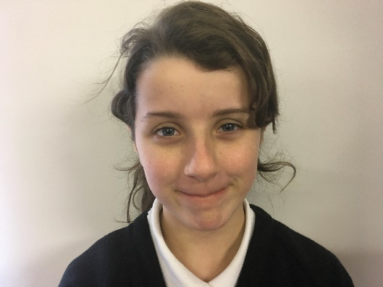

Connie Wooding



Russell Rawlings