Holiday Activity Fund
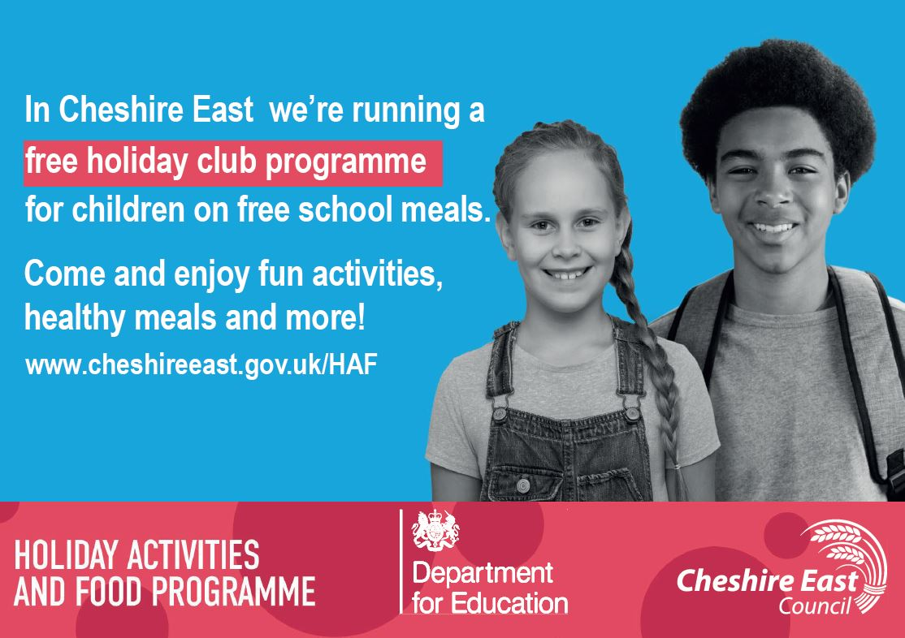

Applications are now open to enrol children and young people in a free holiday activity over the summer.
Free places are now available for children and young people eligible for free school meals. This opportunity is provided as part of the government’s expanded Holiday Activities and Food (HAF) programme being delivered across Cheshire East.
The scheme provides enjoyable activities and nutritious meals for primary and secondary school aged children who are eligible for benefits-related free school meals.
Children will be able to access hundreds of free sessions throughout the summer holidays, including specific provisions available for children with SEND or additional needs. The sessions will include a variety of fun activities, including sports, music, arts and other exciting opportunities to learn and develop skills, alongside a nutritious meal each day.
To view the activities and find out how to book a place, visit www.cheshireeast.gov.uk/FIS and clicking on the ‘things to do’ section or by searching ‘family information service events’. Any families who don’t have access to the internet are advised to contact a professional they are working with who can enrol on their behalf.
For more information about the programme in Cheshire East visit www.cheshireeast.gov.uk/HAF
We’re working with local schools, voluntary and community organisations, and childcare providers to provide the HAF programme. The free places are funded by the Department for Education. Visit the government website for more information.

