General Information Updates

HATE CRIME
JUNE 2015
Hate crime is any criminal offence committed against a person or property that is motivated, or perceived to be motivated, by hostility or prejudice based upon the victim's:
- race, colour, ethnic origin, nationality or national origins
- religion or belief
- gender or gender identity
- sexual orientation
- disability
- age

Everyone has a right to live without fear and harassment and if an offender targets a victim because of how they look, their gender identity, sexuality or because of their beliefs, the law provides additional penalties.
It is important that schools have a good awareness of hate crime as a child in school may be living in a family which are either victims or perpetrators of Hate Crime. Children in school may also be experiencing this from their peers.
Hate crime can take many forms including:
- Physical attacks – such as physical assault, damage to property, offensive graffiti, neighbour disputes and arson.
- Threat of attack – including offensive letters, abusive or obscene telephone calls and other intimidating behaviour as groups or individuals.
- Verbal abuse or insults, abusive gestures.
- Other abuse – offensive leaflets and posters, dumping of rubbish outside homes or through letterboxes, unfounded and malicious complaints and bullying at home, online, in school or in the workplace.

Hate Incidents

Hate Incidents can feel like crimes to those who suffer them and often escalate to crimes or tension in a community. The police can only prosecute when the law is broken but can work with partners to try and prevent any escalation in seriousness.
Prevention
Prevention of Hate Crime ties in closely with Bullying Prevention and PSHE. Pupils should be encouraged to have a good understanding of the issue of Hate Crime so that they can protect themselves and learn tolerance and respect for others.

Reporting
It is important that schools have an understanding of how they themselves, the children or their families can report any incidents of Hate Crime if they occur or where they can get further advice and the details of this are below.There are several ways you can report a hate crime, whether you have been a victim, a witness, or you are reporting on behalf of someone else:

By phone
Call 101 or in an emergency call 999

By email
hate.crime.reporting@cheshire.pnn.police.uk

In person
Come to a local police station or a hate crime reporting centre.

Report online
The police service has launched a website, called True Vision, which allows you to report hate crime online.

4.. Third party reporting centres
- Local agencies such as the Citizens Advice Bureau, Community Voluntary Services etc can also report the incident on your behalf and provide you with advice and support.
- Stop Hate UK provide confidential and independent Hate Crime reporting services in various areas in the UK including a 24 hour helpline.

We also have 2 schools trained as Reporting Centres in Cheshire East: All Hallows Catholic College, Macclesfield and South Cheshire College, Crewe.
These School Reporting Centres are not open to the public to report, but they are schools which have undertaken additional training to support pupils and their families and have embedded the issues into their curriculum.
The centres are about education and working with young people who perpetrate this behaviour, it is about breaking down barriers and promoting harmony and tolerance of others. The Schools/Colleges and their pupils have embraced the following standards:
- Avoid the use of words or behaviour that may cause offence whether intentionally or unintentionally
- Treat every member of your school appropriately, fairly and without discrimination
- Actively identify and challenge inappropriate or hurtful words and behaviour
- Recognise that even though hurt may be unintended it does not make it less harmful in its effect; and
- Recognise the way to treat people fairly and without discrimination is not to treat everyone as the same, but to recognise and respect differences between each other
For details on how to become a reporting centre please contact Cheshire Police on 01606 362003.

Resources
Free CPS Hate Crime Schools Project with PowerPoint presentations and lessons:

http://www.cps.gov.uk/northwest/working_with_you/hate_crime_schools_project/

Good leaflets explaining hate crime in an easy to understand format and details about the Hate Crime Awareness Week:

http://www.stophateuk.org/

Good information and downloadable leaflets and posters about Hate Crime

http://www.stonewall.org.uk/what_we_do/campaign/9286.asp

Good general information and information on reporting Hate Crime

http://report-it.org.uk/what_is_hate_crime

http://www.cheshire.police.uk/advice--information/hate-crime.aspx

The dates for Hate Crime Awareness Week 2015 are from Saturday 10th October – Saturday 17th October
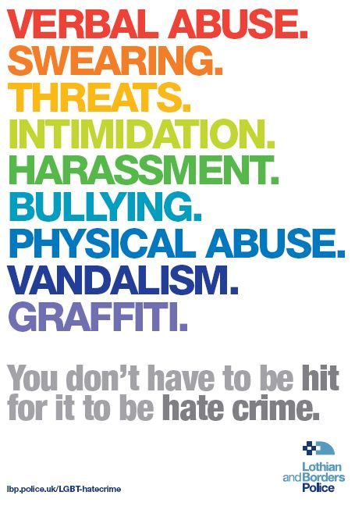

Contact Details: SCIESTeameast@cheshireeast.gov.uk Tel No: 01606 275039
www.cheshireeast.gov.uk

