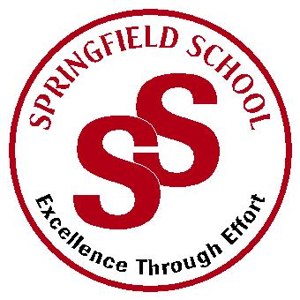**Springfield School**



Crewe Green Road, Crewe, Cheshire CW1 5HS t: 01270 685446 f: 01270 258281

e: admin@springfield.cheshire.sch.uk www.springfield.cheshire.sch.uk

|  |  |
| --- | --- |
| Headteacher: Lisa Hodgkison BA (Hons) | **SEN SPECIALIST** |
|  | **SCHOOLS** |



Sunday, 03 January 2021

Dear Parents and Carers,

I am writing to update you on our position regarding opening on Wednesday 6th January. We are aware that this is a very concerning time for the whole school community and many parents have worries and concerns in relation to the new variant of COVID.

**As it stands this evening we will be opening on Wednesday 6th January** for all pupils unless they are self-isolating. As you are fully aware the situation can change rapidly and we will endeavour to keep you updated as we receive advice and guidance. As parents you may make your own decisions about sending pupils to school based on your own individual and family circumstances. We will support you fully in those decisions and **would not seek to implement any penalty notices.**

We will be testing all staff on Tuesday as detailed in my previous letter, the outcome of this could have an impact on staffing levels, again I will keep you notified as the picture emerges. I will be writing out to parents of pupils within the Secondary and Sixth Form Department tomorrow regarding testing, as outlined previously **this is completely down to parental choice and is a voluntary initiative.**

We continue to implement safety measures as outlined in the main COVID 19 risk assessment to keep all of our school community as safe as we possibly can. You will find the full details of this risk assessment on the website.

If you do have any questions or concerns with regards to your child returning to school, I will be available Monday and Tuesday to discuss. Please either email [head@springfield.cheshire.sc.uk](mailto:head@springfield.cheshire.sc.uk) or leave a message on the school phone system.

Thank you for all your continued support.

Kind Regards

Lisa

Lisa Hodgkison

Headteacher