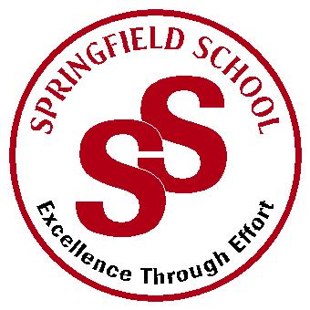
Springfield School
Job Description – Class Teacher

Main Responsibilities
To ensure the effective learning and teaching of pupils for whom the post holder has responsibilities.

Responsible to
The Assistant Headteacher and appropriate line managers as defined within the school leadership and management structure.

Curriculum
To plan and deliver, within the context of the school’s curriculum framework and school improvement plan, an appropriate curriculum for the pupils of Springfield School which:

- is broad and balanced and meets the declared aims of the school.
- is appropriate to the individual learning needs of the pupils.
- is responsive to the equalities policies of the school.
- is within the timetable framework as planned by the leadership of the school, which will reflect national and local requirements.
- looks for inclusive opportunities as a means to develop children’s learning.
- promotes spiritual, moral, cultural and physical development
- prepares pupils for the transition to adolescence and adulthood

Assessment, Reporting and Recording
- To provide ongoing assessment of pupil’s progress in line with school procedures and practice
- To maintain a high quality of teaching by ensuring consistent monitoring and evaluation of own practice.
- To provide reports and Personal Learning Plans on pupil’s progress as required by school leadership, which meet both statutory and school requirements

Learning and Teaching
- To undertake a full teaching commitment within a class and across the key stages as required.
- To plan for children’s differentiated learning within the school’s planning framework using a variety of approaches and strategies.
- To maintain good order and discipline and a positive approach to the management of behaviour in keeping with the ethos promoted in the schools policy on positive behaviour.
- To ensure that positive, trusting and supportive working relationships
between pupils and colleagues are maintained.
- To manage, motivate, develop and support staff with the aim of effective delivery of the curriculum to pupils.
- To maintain an organised classroom environment suitable to the learning needs of the pupils and to contribute to display across the school with reference to the display policy.
- To maintain and develop appropriate and adequate resources for teaching.
- To ensure the health and safety of staff and pupils in accordance with school practice and policy.

Parents and other agencies
- To have a positive approach to involving parents and carers in their child’s education.
- To provide parents and others with detailed information about their child’s progress as required.
- To engage parents in partnerships that will enhance the pupils’ cognitive, emotional and social development.
- To liaise with parents, carers and support services as appropriate and in consultation with the Leadership team.
- To actively work within the safeguarding policy and practice of the school
- To work in partnership with school based support services such as therapists.

School Development
- To work within and towards the framework of the National Standards for Teachers
- To lead on an area of the curriculum to be agreed with the school and in line with school needs.
- To contribute actively in whole school and curriculum development within the context of the school improvement plan.
- To participate in continuing professional development.
- To keep abreast of general and national curriculum initiatives.
- To participate in working parties for the development, maintenance and evaluation of specific curriculum areas.
- To provide advice, assistance and guidance for staff as required.
- To keep staff and governors informed of development

General
- To participate in the corporate life of the school.
- To participate in the school process of performance management.
- To supervise and teach any pupils whose teacher is absent and for whom alternative cover has not been obtained.
- To work with and give appropriate guidance to students, volunteers etc and to contribute to the writing of progress reports etc on them.
- To carry out any other professional duties within the school that may be reasonably required by the Leadership team.
- To carry out duties as described within the School Teachers’ Pay and
- Conditions Document.
- To be responsible for the leadership of a class team.
- Be aware of and comply with policies and procedures relating to child protection, health, safety, security and confidentiality, reporting all concerns to an appropriate person to ensure pupils’ wellbeing.

