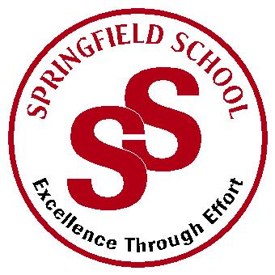**Springfield School**



Crewe Green Road, Crewe, Cheshire CW1 5HS t: 01270 685446 f: 01270 258281

e: admin@springfield.cheshire.sch.uk www.springfield.cheshire.sch.uk

|  |  |
| --- | --- |
| Headteacher: Lisa Hodgkison BA (Hons) | **SEN SPECIALIST** |
|  | **SCHOOLS** |



Friday, 18 September 2020

Dear Parents and Carers,

We have had another wonderful week at Springfield. You will be able to see some of the fantastic achievements in this week’s newsletter.

We have started to see an increase in general winter illnesses alongside pupils and staff with COVID symptoms. I have attached a poster which outlines what to do if you or your child has COVID symptoms.

In terms of general illnesses please be mindful that many of our children do need assistance in personal care. We are aiming to prevent the spread of germs within bubbles. If you child is generally unwell with a cough, cold etc please keep them at home while they recover.

Many thanks to those parents who have kept children at home with the beginnings of cold symptoms this week. This does help with limiting the spread of germs within bubbles. Just as a reminder:

**Your child should be OK to come to school:**

* if your child develops cold-like symptoms but is not coughing and sneezing

**You may choose to exercise caution by keeping your child off school:**

* If they have had a rough night and have had insufficient sleep with cold symptoms.
* If they have also developed a sneeze and are spreading germs this way.

**Your child should stay off school:**

* If they have a high temperature alongside cold symptoms
* If they are exhibiting the key signs of the Covid virus – temperature, continuous cough loss of taste – in this case, you should arrange a Covid-19 test and inform school.

If your child is poorly during the school day, we may ask you to collect them.

If you do have any questions and concerns, please let us know at your earliest convenience and we will endeavour to support and help.

Kind Regards

Lisa

Lisa Hodgkison

Headteacher