Newsletter 22

19th March 2021

Message from the Headteacher
It has been lovely to see all our Super Hero's today, some fantastic costumes and we have had lots of fun. A big thank you for supporting Comic Relief with us.
We are working towards pupils accessing more activities after Easter in line with DfE guidelines, this will include PE. Your class teacher will be in contact with further details.
Testing continues to take place for staff twice a week and pupils once a week for those who can self swab. Testing will continue during the Easter holidays for staff, this continues to play our part in keeping our school community safe.
School closes on Thursday 1st April for Easter.
Have a lovely weekend
Lisa

News and Information

New Phone Number
Please note that our phone number has changed.
01270 691900.
All other contact details remain the same.

Uniform
Just a reminder about uniform, we understand children have grown during lockdown so uniform may be on the small side! If you do require new uniform you can order from here http://springfield.gooddies.co.uk/. Uniform does not need to be branded and can be purchased from any clothes store.
Please note pupils require black shoes in school unless they have specialist footwear.

Sunday 21st March 2021 is World Down Syndrome Day, a global event to raise awareness of and celebrate Down Syndrome. On Monday 22nd March, Springfield staff and pupils are invited to come to school wearing their brightest, craziest, mismatched socks to show their support for Down Syndrome Awareness. For more information on this event or to make a donation to the Down's Syndrome Association, you can visit https://www.downs-syndrome.org.uk/about/campaigns/world-downs-syndrome-day/ or watch 'What is World Down Syndrome Day' https://www.youtube.com/watch?v=Y6L7SgvFPgQ

Comic Relief Day
The children have enjoyed coming to school dressed as their favourite Superheroes. The theme this year is 'Power of Funny' and classes have shared some of their favourite jokes, here are a few of them: Where do most superheroes live? Cape Town! How do you get Pikachu on a bus? You Pokemon! What do you call a cheese that's not yours? Nacho Cheese! What sound does a witches car make? Broom! Broom!

PA Support
Attached are details of agencies recommended by Cheshire East Shortbreak team which you might find useful for PA support.

Weekly Inspiration
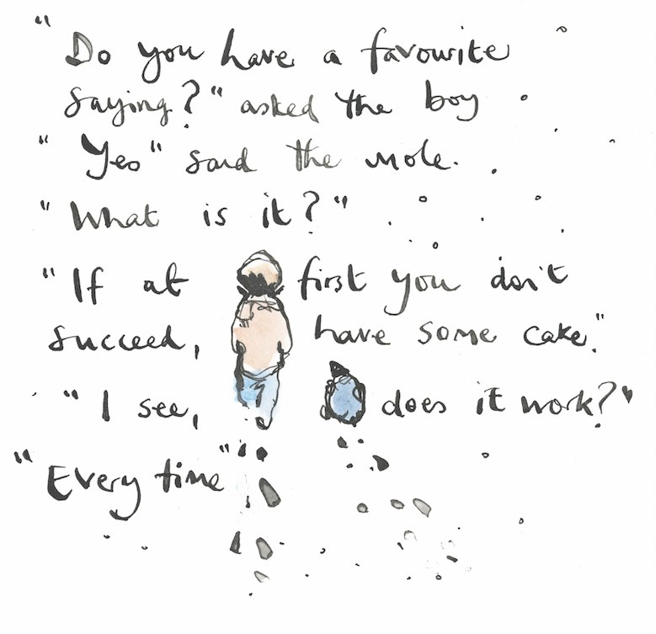
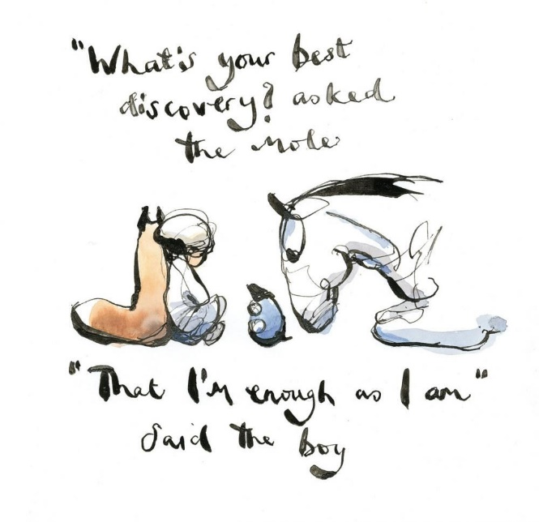
This weeks inspiration has been shared by Class 2SR.

Friends of Springfield
AGM We will be holding our Friends of Springfield AGM on Tuesday 30th March at 12pm via Microsoft Teams. If you would like to join us, further details can be found at https://www.facebook.com/groups/friendsofspringfieldschool. Alternatively please email Judy Colclough at judy.colclough@springfield.cheshire.sch.uk. LOTTERY
Friends of Springfield School have launched a lottery to support Springfield School. Details can be found in the separate email. You have to be In It to Win It!! EASTER EXTRAVAGANZA RAFFLE
Look out for our Easter Extravaganza Raffle coming soon to our Facebook page.
If you would like to donate anything for the raffle, please contact Judy on the above email or message via the Facebook page. MARKET PLACE
Look out for the hand crafted gifts for sale on our Facebook page and our FOS Market place. There are some lovely ideas for Easter gifts.

Reminders
NUT FREE SCHOOL
For new and existing parents please remember that we are a Nut Free School and be mindful of this when sending in snacks or packed lunches.
DINNER MONEY
Please make sure that you pay for your child's school dinners regularly.
Current school meal prices are:
Primary aged pupil (year 3-6) - £2:30 per meal
Secondary aged pupil (year 7 and over) - £2:50 per meal

Please ensure that all dinner money is paid via ParentPay, reminders are sent out by email.
If you have any problems with this, please contact us in school. Please note however, that we are unable to help with resetting passwords for ParentPay, you will need to do this from the login screen.
If your child is not currently receiving free school meals and you think you may be eligible to claim, please contact Cheshire East Council.
SPRINGFIELD SENSORY FACEBOOK PAGE
There is a private Facebook page for staff and parents called 'Springfield Sensory'. This group contains lots of resources which parents may find useful at home and which are suitable for all abilities. You can identify it by the logo shown.
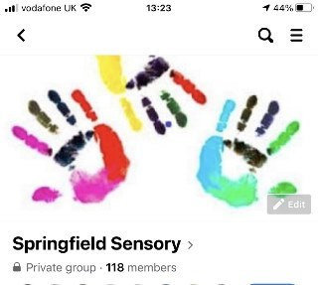

Our NHS Team

Nursing Team
Could parents/carers let the Nursing Team know of any changes in their child’s conditions/medications/ A & E attendances etc via eSchools to Jenny Smith, Katie Mulroy or Debbie Potts. Parents can e-school, send letters or call us. We are in school between 8.30am and 16.30pm each week day.
Direct phone numbers to the nursing team are:
01270 826151 there is an answerphone on this.
01270 826150 there is no answerphone on this.
The new number to call for any continence issues or change of size of nappies is 01270 826360.

Physiotherapy and Occupational Therapy
If you have any questions regarding your child’s physio/OT/Orthotics care, the team can be contacted via eSchools, or telephoning school and asking for the Therapy Department. Could you please let us know of any upcoming orthopaedic appointments or planned surgery that has been scheduled for your child. Hayley Mitchell, Physiotherapist is in school Monday to Friday and Yvonne Williams, OT works on a Monday.
Useful contact numbers
For wheelchair reviews:
Physio/OT office: 01270 826153
Wheelchair assessment unit: 01625 663345
Wheelchair repairs: Rosscare 0151 6536000

Speech Therapy
We are always keen to hear from you - please feel free to contact us with any questions about your child's treatment.
Jo Currie is available Monday, Tuesday, Wednesday
Alex Makin is available Wednesday (pm), Thursday, Friday
Phone the school on 01270 685446 or on direct line 01270 826152.
EmaIl: joanne.currie2@mcht.nhs.uk
alex.makin@mcht.nhs.uk
Or contact via eSchools

Contact Us
If you need to contact us :
Springfield School
Crewe Green Road
Crewe
CW1 5HS
Telephone: 01270 691900
Email: head@springfield.cheshire.sch.uk

