**Springfield School**

**Anti-Bullying Ambassador**

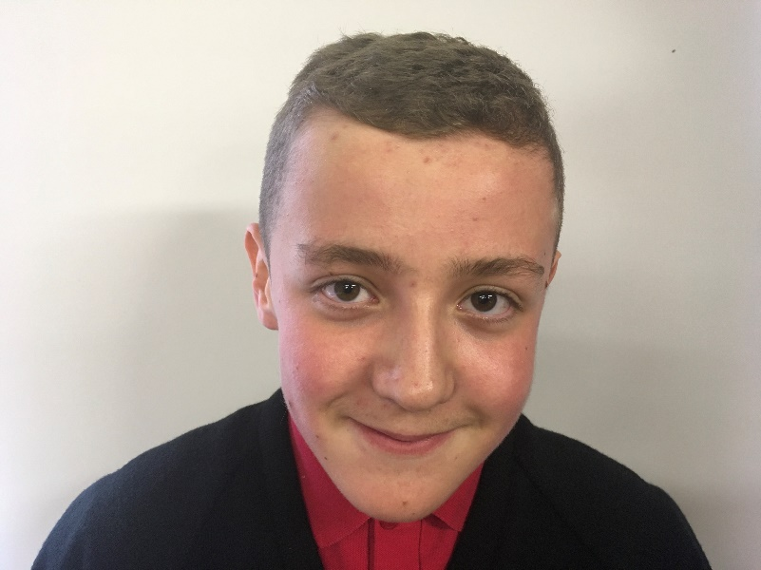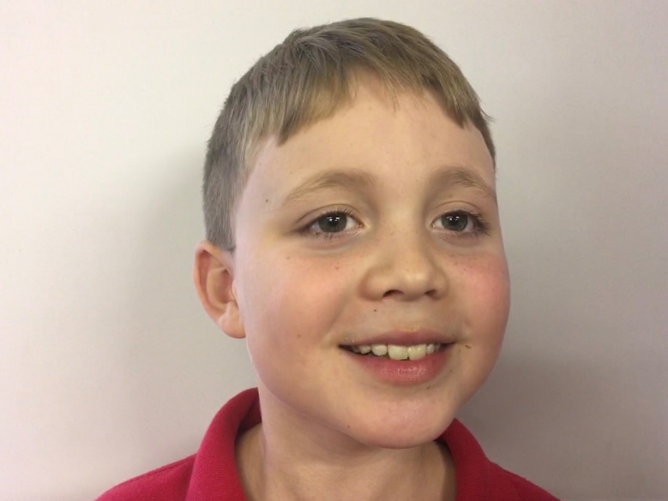

Robbie Hall Albert Evans