Children, Young People and Domestic Abuse

January 2017
Domestic abuse negatively affects children and young people. We know that they are often more aware of what is happening than parents think. How they respond depends on their age, personality and support network; but they recover best when they are helped to understand and to process what is happening/has happened to them.

Their experiences will shape their self-worth, identity, and ability to relate to others in childhood and adulthood; making it much more difficult to succeed at school and develop friendships.
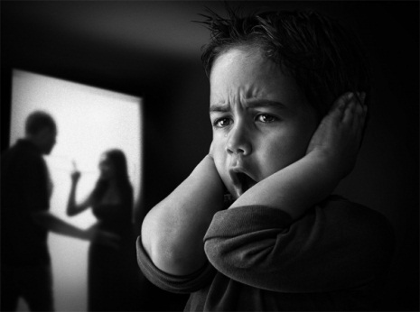

What can schools do?
Children and young people need to feel a sense of control after an incident, to this end school may be their safe place where things feel ‘normal’. Schools can support children and young people who have experienced domestic abuse by:

- Having an ethos which puts children’s wellbeing at the heart of all that they do
- Creating a predictable school life with set routines.
- Ensuring that rules and expectations are clearly stated and understood by all.
- Understanding that oppositional and manipulative behaviours are not attempts to ‘provoke us’, but may be attempts by these children to control their world when so much feels out of control for them
- Modelling respectful and caring behaviour, positive conflict resolution and respectful interactions. Helping children learn not only what not to do, but what to do instead.
- Using the language of choice, making clear the benefits and negative consequences of their choices. Ensuring that you follow through with any consequences or sanctions.
- Supporting children to put feelings into words. Build up a vocabulary of emotional words with them so that they can begin to express their feelings more appropriately/accurately. (A child exposed to domestic abuse may have seen a lot of behaviours that express strong feelings, but may not have heard words to appropriately express/ describe these feelings).
- Understanding that the child may experience conflicting and confusing emotions when thinking of or talking about their parents.

- Creating opportunities for children to feel successful.
- Letting the child/young person know that they matter; taking an active interest in them.
- Accepting that they may not be willing or able to talk about it right away (if ever)
- Providing effective, non-verbal, systems for children and young people to access support
- Providing reassurance that only people who need to know about the incident will know.
- Allowing the child, where necessary, to safely store work in school or indeed shred it after completion when providing interventions
- Having visible and accessible worry boxes/internal support systems

- Having visible and accessible information regarding sources of support e.g. Childline etc.

Implications for practice
When supporting a child or young person:

- Avoid asking them leading questions
- Allow them to go at their own pace.
- Never promise confidentially
- Use active listening skills; listen quietly and attentively, being non-judgemental
- Occasionally summarise, restate
- Reassure them: ”I’m glad you came to me”, “You are not to blame”, You have been very brave to tell me”
- Use the “TED” approach:
Tell me what you mean by that?
Explain that to me
Describe that to me

Child to parent abuse:
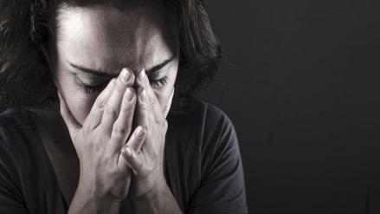

Parents can be abused by a child or teenager. A young person is capable of inflicting emotional, verbal and physical abuse, but it is often misunderstood or minimized because of their age. Age can be deceiving and is no indication of a person’s ability to inflict harm; no one may know unless the parent speaks up

Disagreements, conflict and arguments are a normal part of family life at times; however sometimes the young person can be abusive or violent; exerting power or control over their parents. It can happen in families of any culture, religion or situation in life.

Violence or abuse can be a sign that the young person:

- hasn’t learnt to control or manage their feelings, especially anger. They act out their feelings without using any self-control
- hasn’t learnt to deal with the stresses of life, to solve problems or cooperate. They might think it’s their right to have all their demands met above others (sense of 'entitlement')
- doesn’t value or respect other people, or their property
- sees a parent, often the mother, as weak and powerless or think it’s OK to treat women this way
- is affected by alcohol or drugs. Some drugs can trigger psychosis (being out of touch with the real world) and violence.
- may have problems with their mental health. They may be anxious and lash out because they start to think they can’t trust those around them.
- may feel frustrated or have trouble dealing with their feelings. They may find it hard to say how they feel or struggle to control their impulses ; sometimes this can be linked to a disability
This can feel quite frightening for the young people as well as the parents

Schools can support by raising awareness amongst staff; empowering them to raise it with parents where there are indicators; signposting those parents to support.

Young people themselves can be in abusive relationships what should the school be aware of?
Young people in Cheshire East are sometimes identified as being in their own abusive relationships; either inflicting abuse on others or being abused within that relationship. Schools may pick up on the signs or other peers may identify the abuse; therefore it is important that staff and pupils are made aware of the signs.

Some of the signs below could indicate that a young person is experiencing relationship abuse. This list is not exhaustive and young people respond differently. These signs could also be due to other causes, but it is useful to be aware of common responses:

- Truancy, late/early arrival to avoid the abuser (especially if attending the same school)
Contact Details: SCIESTeameast@cheshireeast.gov.uk Tel No: 01606 275039
www.cheshireeast.gov.uk
- Falling grades
- Being withdrawn, passive, compliant
- Changes in mood and personality
- Isolation from family and friends
- Frequent texts and calls from boyfriend / girlfriend
- Inappropriate sexual behaviour/ language / attitudes
- Depression
- Physical signs of injury / illness
- Pregnancy
- Use of drugs / alcohol (where there was no prior use)
- Self-harm
- Eating disorders or problems sleeping
- Symptoms of post-traumatic stress
- Not focussed in lessons / poor concentration

Safeguarding Children and Young People affected by Domestic and Relationship Abuse
To support effective communication and response a policy document has been written for all education settings, agencies and services in Cheshire East.

There are two versions, one is intended for young people themselves and the other is for those working with our children and young people.

To access these documents click: Domestic Abuse

Sources of support:
Cheshire East Domestic Abuse Hub:
CALL 0300 123 5101  EMAIL cedah@cheshireeast.gcsx.gov.uk  Text 0777 194 1464 | 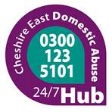
Resources:
Act on it now - Act On It Cheshire East’s site for healthy relationships

This is ABUSE a website for young people looking at different types of relationship abuse

Resources - Act On It links to films, Educational Toolkits, websites and books

www.rapecentre.org.uk and www.cheshiresarc.org.uk Rape and Sexual Abuse Support Centre 0330 353 0063 Independent Sexual Violence Advisors and Counselling for children.

Training:
Cheshire East’s SCiES team offer training for whole school staff around Domestic abuse and the impact on children. Do contact the team if you would like to book a session sciesteameast@cheshireeast.gov.uk

If you have concerns that a child is at risk you should contact Cheshire East Consultation Service (ChECS) and/or Cheshire East Police without delay:
ChECS: 0300 123 5012
Cheshire East Police: 101 or in urgent cases dial 999

