At Springfield school we recognise how important it is for pupils to be able to regulate and manage their behaviour appropriately, understand their feelings and emotions, make sense of the world around them and significant life events that take place whilst continuing to access areas of the curriculum. To support our pupils to do this we have created a purpose build Behaviour and Therapy Centre.
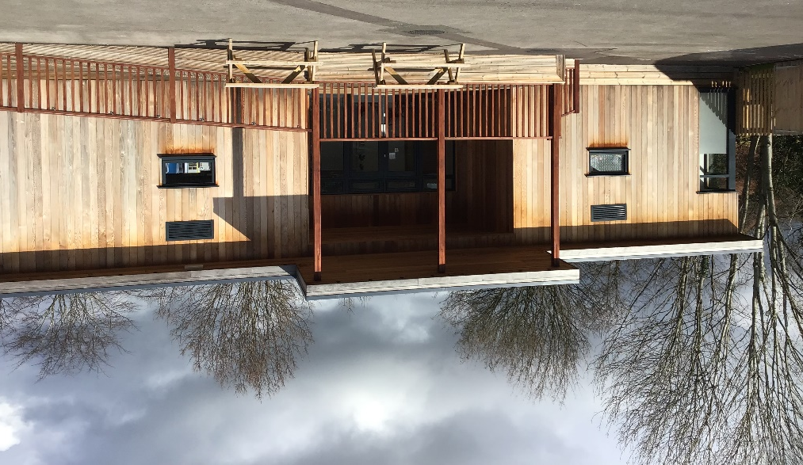

Our therapy centre is a separate building set within our school grounds. The centre is split into two areas, therapy and behaviour and has its own outside garden area. The centre provides a quiet, calm and nurturing environment for our pupils to learn new skills and manage life events, preparing them for life after Springfield School.
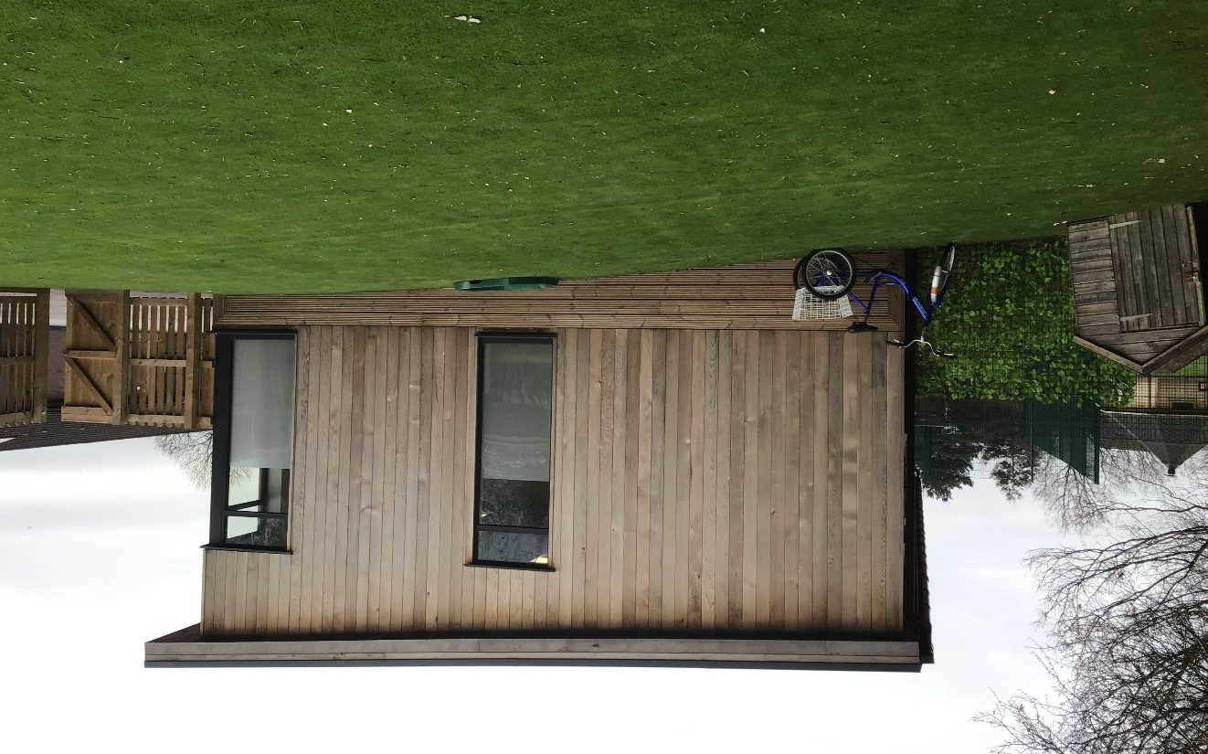

Our therapy classroom is calm relaxing environment that can house sessions such as Play Therapy and Lego Therapy, with two smaller therapy rooms that provide space for 1.1 therapies.

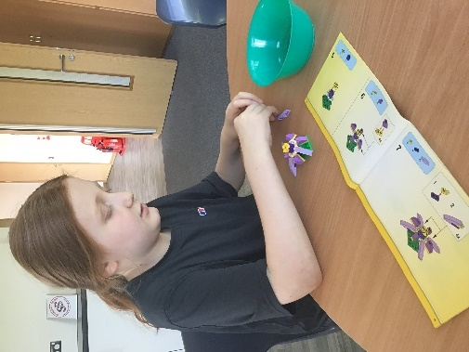
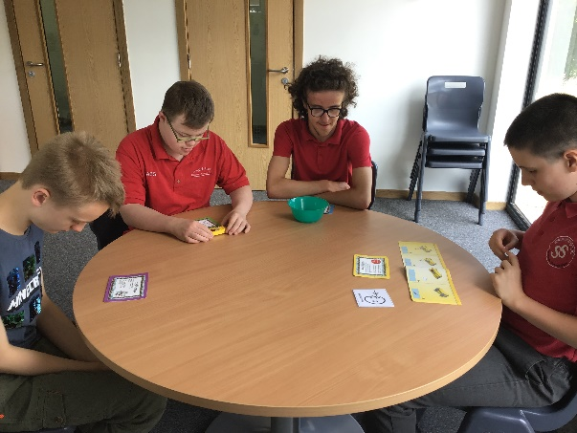

Our behaviour classroom is smaller than a typical classroom that you would find throughout Springfield school but is set up to follow the same routine, with timelines, transition traffic lights and timetables in place. This side of the centre also has three break-out spaces that provide pupils with a smaller calming space where they are encouraged to recognise and regulate their emotions safely and appropriately. Pupils who access this area will have a high level of staff support whilst following their own bespoke timetable to meet their current circumstances and needs. Pupils still follow elements of the daily routine that is consistent part of a Springfield school day, i.e circle time, sensory circuits and playtimes.

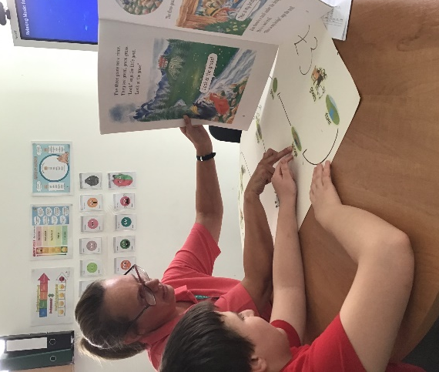

Behaviour and Therapy Support
At Springfield we have a three-tiered approach to supporting our pupils and any behaviours of concern. Our Behaviour and Therapy Centre team support pupils all the way through the tiers, whilst providing continuous support for staff working with pupils and working closely with parents. Pupils can move freely between the tiers and are able access support within the tiers for a duration of time that is appropriate for their own individual needs.

Level 3
Long Term Therapy Centre support
Level 1
Classroom behaviour support/ strategies
Level 2
Therapy Centre based support

Level 1
At level 1 pupils and class teams access support from the Behaviour and Therapy Team. This support normally takes place in the classroom with observations carried out on pupil behaviour, attending class team meetings, supporting staff to implement suggested behaviour strategies, and working with pupils within their classroom setting. The team may also support class teams to create and implement Positive Behaviour Support (PBS) Plans.

Level 2
At level 2 our pupils require specialist support outside of the classroom and will access specialised behaviour support and alternative therapies. This support is offered in the form of short-term behaviour interventions, nurture sessions, ELSA sessions, Lego Therapy and Play Therapy. All therapies are led by specialist within their field.

Level 3
Level 3 is our highest level of behaviour support. Pupils accessing tier 3 support are based in the Therapy Centre and require long term, intensive behaviour support from highly skilled and experienced members of staff. Pupils will then be supported to transfer and generalise the skills acquired at this level to the classroom and if required offsite.

