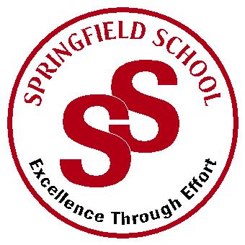
Springfield School
Crewe Green Road, Crewe, Cheshire CW1 5HS t: 01270 685446 f: 01270 258281

e: admin@springfield.cheshire.sch.uk www.springfield.cheshire.sch.uk

Headteacher: Lisa Hodgkison BA (Hons) | SEN SPECIALIST
 | SCHOOLS
Friday, 20 March 2020

Dear Parents and Carers,

I am sure you will be aware all Schools in England will close at the end of the school day tomorrow for all pupils except those whose parents work in critical services, those known to social care and have an EHCP under the at-risk category.
We have made every effort to open our doors during difficult times over the last few weeks, but our staffing levels are now critical. We will not be accommodating all pupils on EHCP due to critical staffing levels.

The Public Health England’s advice is that anyone with a learning disability or cerebral palsy or any other underlying health condition should self-isolate. This applies to all our pupils however; alongside the Government guidelines we will still be providing a reduced provision for:

- Pupils with parents who are key workers (Please see note below)
- Pupils who have Social Work involvement and at risk of family breakdown
- Pupils who are Cared For

School is closed to all other pupils that do not fall into these three categories.

If you have someone who is 18+ living in your household who can look after your child, eg partner, other parent not in the household, extended family not in a risk category, older sibling, or are working at home, I would not classify you as a Key Worker and your child should not come to school.

School in its current capacity will close for all on Friday 20th March. School will remain closed on Monday to facilitate a deep clean and plan for ‘reduced provision’ for the pupils in the above three categories, please note this will not be Education. Work and activities for students at home will be emailed over to by Monday and we will still be available through eschools to answer any questions. The provision will be reviewed on a daily basis, for the next two weeks. We will then close for Easter as planned. Parents who are eligible for the reduced provision will be contacted by 1pm today.

We trust you will appreciate we are working directly under Government and Public Health guidelines to ensure we accommodate as many pupils as possible under the most vulnerable categories, with the staffing and resources we have.
Our staff and the children we care for are continuing to place themselves at increased risk by being in schools. We do this to support our key workers and the most vulnerable children, standing together for our community and professional colleagues.
I want to take this opportunity to thank you all for your support during uncertain and difficult times.

Kind Regards

Lisa Hodgksion
Headteacher

Providing an outstanding educ
ation for all our pupils

