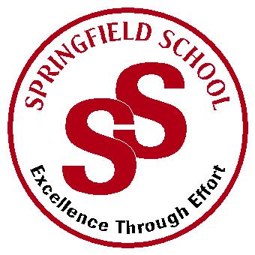**Springfield School**



Crewe Green Road, Crewe, Cheshire CW1 5HS t: 01270 685446 f: 01270 258281

e: admin@springfield.cheshire.sch.uk www.springfield.cheshire.sch.uk

|  |  |
| --- | --- |
| Headteacher: Lisa Hodgkison BA (Hons) | **SEN SPECIALIST** |
|  | **SCHOOLS** |



Thursday, 16 April 2020

Dear Parents and Carers,

I am writing to you to update on the current **COVID 19** situation. I hope you are all well and safe and have managed to take advantage of the nice weather during the Easter break.

We understand that the current status for school will remain the same for the foreseeable future. We appreciate that this is a very difficult situation for all our children, but **we need to emphasise that children are safest at home.** I am sure you will appreciate these are very unprecedented times and we are all working hard to keep our pupils and staff safe.

To keep both pupils and staff safe the Government guidelines state that we should have as few pupils in school as possible to reduce the possible spread of infection of COVID 19. One of the biggest difficulties with our **pupils is their inability to socially distance themselves away from others**, so pose an even greater risk to pupils and staff working with them. Alongside this our pupils need closer supervision and therefore require more staff in one classroom area again increasing the risk of the spread of the infection. We are also awaiting further guidance on PPE equipment for intimate care, there are still no firm guidelines on protecting staff when they are providing this level of care.

Due to an increase in Key Worker shifts after the Easter period we will be changing our system to ensure that we do not put pupils or staff at risk.

There are **two categories** of pupils that will be in school after Easter:

* **A parent as a Key Worker (This will be when the parent / parents are working - not a full-time provision)**
* **A child with a Social Worker who is at risk of a family breakdown.**

**For a child with an EHCP the guidance from the DfE states:**

*Those with an EHC plan should be risk-assessed by their school/college in consultation with the local authority and parents, to decide whether they need to continue to be offered a school/college place in order to meet their needs, or whether they can safely have their needs met at home. This could include, if necessary, carers, therapists or clinicians visiting the home to provide any essential services. Many children and young people with EHC plans can safely remain at home.*

**As a Leadership team we have assessed every pupil in school in conjunction with the Local Authority and Social care to assess risks and have spoken to the relevant parents where we feel there is a significant risk.** For those children where this is applicable, and they don’t fall into the medical category you will have already **received a text message confirming your child’s place.**

We will continue to offer **distance learning for every child** this will involve a weekly planner of activities, online sessions where possible and a personal phone call / email from your class teacher. I am available to be contacted at anytime through e-mail or by leaving a voice mail on the school answerphone.

I want to take this opportunity to thank you all for your support during uncertain and difficult times.

Kind Regards

L Hodgkison

Lisa Hodgksion

Headteacher