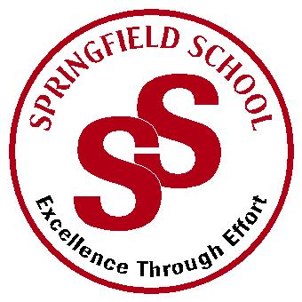
Springfield School

Crewe Green Road, Crewe, Cheshire CW1 5HS t: 01270 685446 f: 01270 258281

e: admin@springfield.cheshire.sch.uk www.springfield.cheshire.sch.uk

Headteacher: Lisa Hodgkison BA (Hons) | SEN SPECIALIST
 | SCHOOLS
SPRINGFIELD SCHOOL
Would you like a new challenge in an OUTSTANDING Special School for students and pupils between the ages of 4-18 with a range of Special Educational Needs in a friendly, supportive school, passionate about enhancing all aspects of education for our pupils?
Springfield school is an Outstanding special school catering for pupils and young people with significant special needs. The school offers classes with a high staff to pupil ratio managed by experienced and qualified teaching and classroom support staff.
We are recruiting for:
Maintenance Support Officer
Position suitable for College Leaver (On the job training provided)
SALARY RANGE: Grade 2
SALARY: £17, 235.99
HOURS: Permanent/Full-time/Term Time + 4 Weeks /37 hours per week – 9.00am-5.30pm
START: ASAP

Do you have the following?
- A commitment and passion to support the outcomes and life chances of young people with complex special educational needs
- The ability to be forward thinking and support staff and pupils with their ICT requirements
- The ability to use initiative to lead projects to ensure IT continues to remain up to date
- An ability to be proactive, resourceful and energetic

We can offer in return:
• A supportive and committed staff team
• A well-resourced and pleasant working environment
• Training opportunities to further your professional development

We are looking for an energetic, motivated and hardworking individual to join our school team and help us to ensure our school provides a safe, welcoming and purposeful environment for children, staff and visitors.
Under the guidance of our Site Maintenance Officer, this varied and hands on role will involve some key holding, opening or closing the school building and maintaining/improving the school facilities and grounds. Knowledge and previous experience in a trade or excellent DIY skills would be useful for this post.
The applicant should have a good sense of humour, be enthusiastic and have a positive approach to work, be able to work independently as well as working as part of a team.
CLOSING DATE: Friday 12th November

Providing an outstanding education for all our pupils

