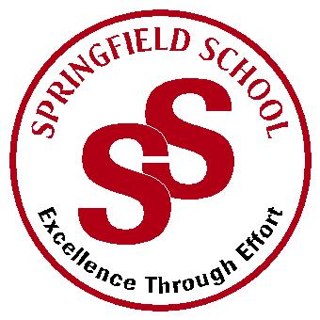**Springfield School**



Crewe Green Road, Crewe, Cheshire CW1 5HS t: 01270 685446 f: 01270 258281

e: admin@springfield.cheshire.sch.uk www.springfield.cheshire.sch.uk

|  |  |
| --- | --- |
| Headteacher: Lisa Hodgkison BA (Hons) | **SEN SPECIALIST** |
|  | **SCHOOLS** |



Wednesday, 02 September 2020

Dear Parents and Carers,

I hope you are all keeping well and safe and enjoyed the summer break. We have continued to work in response to the latest Government guidance to welcome all pupils back to school on Monday 7th September. Preparations are well under way and we are looking forward to seeing all our pupils back in school next week.

The Government requires all pupils to return to school full time unless they have had a specific extension to ‘Shielding’. For those pupils who will continue to shield in September we are currently putting together a Curriculum home schooling offer. If this applies to your child please contact me directly to discuss.

**ARRANGEMENTS AS OF MONDAY 7TH SEPTEMBER**

School has had to be risk assessed in some detail to ensure we remain safe for pupils and staff. Pupils coming into school will be working within bubbles of pupils and staff to reduce risk of contamination. Each bubble is their class group and staff, pupils will remain in their bubbles during the day and will have a dedicated outdoor space. Where needed teachers can move between bubbles to cover PPA as stated in the Government guidelines. Rooms are free of soft furnishings and toys that can’t be wiped down and a rigorous cleaning regime is in place. This method has been tried and tested and has proved to work over the last few months.

We will no longer be taking temperatures of pupils on arrival due to the guidance changing and stating it is not a reliable method to detect COVID 19. If a pupil or member of staff shows symptoms they will be asked to self-isolate and be tested. If a pupil or member of staff does test positive for COVID 19 the bubble will be sent home to isolate for 14 days after we receive the test result to prevent the spread of infection.

Our biggest challenge is going to be accommodating transport for both TSS and parents. We have 22 vehicles from TSS and parent vehicles to accommodate in a very short space of time. Our arrangements for transport have had to change due to COVID, we thank everyone in advance for their patience during the first week.

We are asking parents bringing their child into school to drop off/pick up at the following times, **this will be reviewed after the first week**:

* Morning 9.15am – 9.30am
* Afternoon 2.45pm – 3.00pm

This will help us accommodate our larger vehicles and ensure everyone arrives and departs safely.

**I have attached a frequently asked questions document, which I hope will be useful to you. All risk assessments are available on the main school website www.springfield.cheshire.sch.uk**

If you have any immediate concerns or you wish to discuss your child’s return to school, please do not hesitate to contact me.

We are looking forward to reopening our wonderful school again for all pupils.

Stay safe, and we will see you soon

L Hodgkison

Lisa Hodgkison

Headteacher