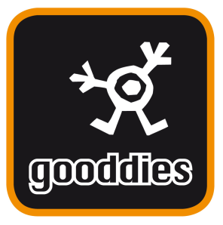

SCHOOL UNIFORM ONLINE ORDERING

Our School uniform is now available to purchase online through our new web store http://gooddies.co.uk

Order Deadline Dates
Orders placed before midnight on the 15th of the month will be delivered approximately the end of the month. Orders placed before midnight on the last day of the month will be delivered approximately the middle of the following month. Please allow up to 20 working days from cut off during the busy months of June – September.

Deliveries into school are free however, you do have the option to pay for home delivery at a cost of £6.50 PLEASE NOTE – Home delivery is not an express option. Any orders that are due for delivery into school while the schools are closed will be held in our warehouse until the school re-opens.

