Newsletter 37

22nd July 2021

Message from the Headteacher
Dear Parents and Carers,
As we all sit and reflect over the last 18th months, I feel so incredibly proud of what we have achieved within our Springfield Community.
Despite the daily challenges we have faced, the continuing changes to government guidance and the opening and closing of schools we have still managed some life changing achievements with our pupils.
Our wonderful children never cease to amaze me, they have carried on through a global pandemic and made us smile each and every single day. With the introduction of Bubbles, increased hand washing, use of face coverings for staff, remote learning, and many more, these measures have not phased our children at all and they have all made progress during the academic year.
I am sure you will join me in thanking our fantastic staff for supporting our children and keeping them safe. We have been very fortunate not to have many COVID cases within school and I put this down to the vigilance of both staff and parents during these uncertain times.
As we reflect what has become very apparent is the importance of strong mutual friendships, fun and laughter and the value of a school community working together as one, supporting each other and helping everyone come through the difficult times.
We are hoping you all have a safe and restful summer, once again we are not sure what the next few months will look like, however, we will be ready for any hurdles that may face us.
Stay safe, take care and we look forward to welcoming the children back into school on Monday 6th September.
Lisa

News and Information

6EM - NCS
On Thursday Hannah Guthrie from the charity Friends for Leisure visited 6EM to accept the cheque for the £328 that the students raised for their NCS project. Hannah explained a little more about the charity and how the money will go to support local children.

Primary Swimming Gala
The Primary swimming gala results are as follows: Green. 148 points Yellow 172 points Red 177 points Blue 184 points Congratulations to the Blue team a fabulous achievement and well done to everyone who took part you were ALL fabulous! Remember to stay safe near water over the holidays!

School Dinners
Please can we ask that you ensure that all school meal accounts are cleared of outstanding payments by the end of term.
The cost of school meals remains the same for September:
- Primary aged pupil (year 3-6) - £2:30 per meal
- Secondary aged pupil (year 7 and over) - £2:50 per meal
We aim to be a cashless school and therefore ask that all dinner money payments are made via ParentPay. If parents do not have ParentPay accounts activated and need assistance, please contact Andrea in Admin.
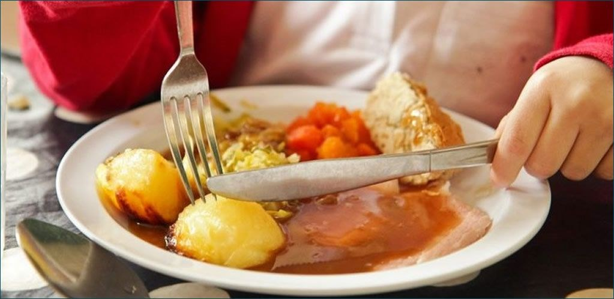

Live Well, Cheshire East
Attached are several leaflets from Cheshire East which you might find useful over the holidays.

The Domestic Abuse Hub
For many families, summer is a time to relax and have some fun, but it can be a difficult period for victims of domestic abuse. While some families spend time apart during the summer, others spend more time together, which can make it harder for those affected to seek help, increasing feelings of isolation.
If your family is experiencing, or has experienced, domestic abuse, or you are concerned that domestic abuse is happening in another home where your child is staying, remember that you and your child are not alone. There are services within Cheshire East who can offer help and support.
Cheshire East Domestic Abuse Hub (CEDAH) offers a single point of contact, information and advice for families affected by domestic abuse and those who support them - formally or informally. If you are concerned about a friend or family member you can get advice about how best to support the person you care about too.
Domestic abuse is never okay or excusable, and everyone has the right to live a life free from fear, harm and control. If you are concerned about your own behaviour we can help you to change the way you behave in your family and relationships.
You can speak to someone by phoning the Hub on 0300 123 5101 or you can get tips and advice from Open the Door.

Friends of Springfield

Friends of Springfield School Lottery
Just a reminder to buy your Friends of Springfield School Lottery tickets.
- Help us raise essential school items
- Support our lottery from just £1 a week
- Guaranteed cash prizes every week
- Win up to £25,000

Reminders

Nut Free School
For new and existing parents please remember that we are a Nut Free School and be mindful of this when sending in snacks or packed lunches.

Springfield Sensory Facebook Page
There is a private Facebook page for staff and parents called 'Springfield Sensory'. This group contains lots of resources which parents may find useful at home and which are suitable for all abilities. You can identify it by the logo shown.
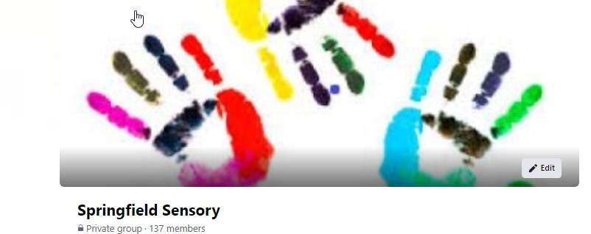

Our NHS Team

Nursing Team

Important
Could parents/carers let the Nursing Team know of any changes in their child’s conditions/medications/ A & E attendances etc via eSchools to Jenny Smith, Katie Mulroy or Debbie Potts. Parents can e-school, send letters or call us. We are in school between 8.30am and 16.30pm each week day.
Direct phone numbers to the nursing team are:
01270 826151 there is an answerphone on this.
01270 826150 there is no answerphone on this.
- New number for parents to activate their pad orders for Cheshire East children: NHS chain supply activation line - 0800 0304466
- The contact number for any issues with pads or if current pads are no longer suitable is: Bowel and Bladder Nurses - 01270 826360

Physiotherapy and Occupational Therapy
If you have any questions regarding your child’s physio/OT/Orthotics care, the team can be contacted via eSchools, or telephoning school and asking for the Therapy Department. Could you please let us know of any upcoming orthopaedic appointments or planned surgery that has been scheduled for your child. Hayley Mitchell, Physiotherapist is in school Monday to Friday and Yvonne Williams, OT works on a Monday.
Useful contact numbers
For wheelchair reviews:
Physio/OT office: 01270 826153
Wheelchair assessment unit: 01625 663345
Wheelchair repairs: Rosscare 0151 6536000

Speech Therapy
Wishing all staff, pupils and their families a wonderful summer holiday! See you all in September!
We are always keen to hear from you - please feel free to contact us with any questions about your child's treatment.
Jo Currie is available Monday, Tuesday, Wednesday
Alex Makin is available Wednesday (pm), Thursday, Friday
Phone the school on 01270 691900 or on direct line 01270 826152.
EmaIl: joanne.currie2@mcht.nhs.uk
alex.makin@mcht.nhs.uk
Or contact via eSchools

Contact Us
If you need to contact us :
Springfield School
Crewe Green Road
Crewe
CW1 5HS
Telephone: 01270 691900
Email: head@springfield.cheshire.sch.uk

